IRL No. | Inventory  No. | Object | Name | Created:  Who  When  Where | Short description | Picture No. | Collection fund code number | Location  Area code No/
003262 |  | Reproduction |  |  | Reproduction of the portrait of Helena Roerich by Svetoslav Roerich | 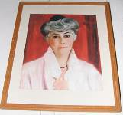 |  | SRM
003263 |  | Photograph |  |  | Photograph (copy) of George and Svetoslav Roerich in childhood, St.Petersburg, 1907 | 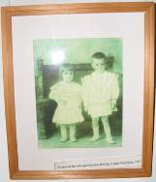 |  | SRM
003264 |  | Photograph |  |  | Photograph (copy) of Svetoslav Roerich in childhood, 1909 | 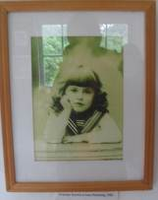 |  | SRM
003265 |  | Photograph |  |  | Photograph (copy) of Svetoslav Roerich in childhood, 1911 | 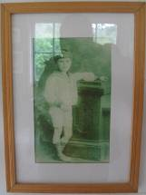 |  | SRM
003266 |  | Reproduction |  |  | Reproduction of the portrait of Nicholas Roerich, 1934 | 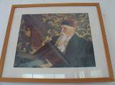 |  | SRM
003267 | Photograph |  |  |  | Photograph (copy) Svetoslav Roerich, 1918-1919 | 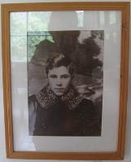 |  | SRM
003268 | Photograph |  |  |  | Photograph (copy) of Svetoslav Roerich, 1923-24 | 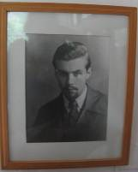 |  | SRM
003269 | IRMT/SRM/003269/Pr_F/ carved wooden stand with 3 shelves / 003269 | Wooden stand |  |  | Roerichs’ carved wooden stand with 3 shelves  Size 101 x 54,5 cm | 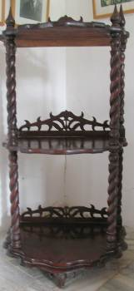 | Pr_F | SRM
003270 | IRMT/SRM/003270/B/ Boris Pasternak, Dr. Zhivago, #378 / 003270 | Book |  |  | Book, Boris Pasternak, Dr. Zhivago, A Novel, Pantheon, 1938, 558 p.  Book from the Library of Devika Rani Roerich with written notes by her, Stamp of the Roerich Memorial Trust  #378 (01/06/93) | 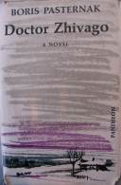  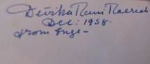 | B | SRM
003271 | IRMT/SRM/003271/B/ Jawaharlal Nehru, the Discovery of India, #384 / 003271 | Book |  |  | Book of Jawaharlal Nehru, the Discovery of India, The Signet Press, Calcutta, 1946, 514 p.  Book from the Library of Devika Rani Roerich with written notes by her, Stamp of the Roerich Memorial Trust  # 384 (01/06/93) | 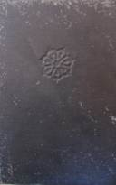  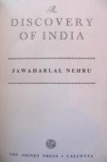 | B | SRM
003272 | IRMT/SRM/003272/B/ S.Roerich, Reflections / 003272 | Book |  |  | Book of S.Roerich, Reflections, 1992, 146 p. | 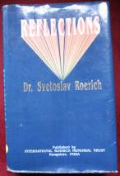 | B | SRM
003273 | IRMT/SRM/003273/B/ Svetoslav Roerich Exhibition 1960-1961 / 003273 | Book |  |  | Book, Svetoslav Roerich Exhibition 1960-1961, Roerich Gallery, Kulu, S.R. Rameswamy, 1974, 228 p. | 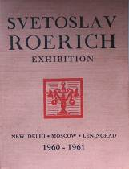 | B | SRM
003274 | 003274 | Book |  |  | Book, Svetoslav Roerich, 1974, 91 p., International Roerich Memorial Trust, 2004, 2 copies |  | B | SRM
003275 | 003275 | Book |  |  | Book, Great Thought, articles by S.Roerich, 189 p. |  | B | SRM
003276 | IRMT/SRM/003276/Oth/ Gramophone record, Linguaphone Language Courses #19-20 / 003276 | Gramophone record |  |  | Gramophone record, Linguaphone Language Courses 19-20  (Roerichs’s collection) | 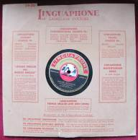 | Oth | SRM
003277 | IRMT/SRM/003277/Oth/ Gramophone record, Linguaphone Language Courses #15-16 / 003277 | Gramophone record |  |  | Gramophone record, Linguaphone Language Courses 15-16  (Roerichs’s collection) | 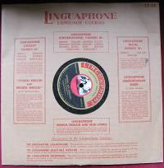 | Oth | SRM
003278 | IRMT/SRM/003278/Oth/ Gramophone record, Linguaphone Language Courses #23-24 / 003278 | Gramophone record |  |  | Gramophone record, Linguaphone Language Courses 23-24  (Roerichs’s collection) | 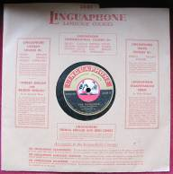 | Oth | SRM
003279 | IRMT/SRM/003279/Oth/ Gramophone record, Linguaphone Language Courses #27-28/ 003279 | Gramophone record |  |  | Gramophone record, Linguaphone Language Courses 27-28  (Roerichs’s collection) | 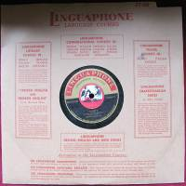 | Oth | SRM
003280 | IRMT/SRM/003280/Oth/ Gramophone record, Linguaphone Language Courses #11-12/ 003280 | Gramophone record |  |  | Gramophone record, Linguaphone Language Courses 11-12  (Roerichs’s collection) | 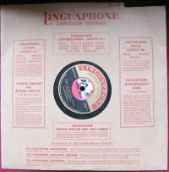 | Oth | SRM
003281 | IRMT/SRM/003281/Oth/ Gramophone record, Linguaphone Language Courses / 003281 | Gramophone record |  |  | Gramophone record, Linguaphone Language Courses  (Roerichs’s collection) | 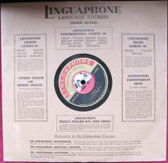 | Oth | SRM
003282 | IRMT/SRM/003282/Oth/ Gramophone record, Linguaphone Language Courses, #3-4 / 003282 | Gramophone record |  |  | Gramophone record, Linguaphone Language Courses 3-4  (Roerichs’s collection) | 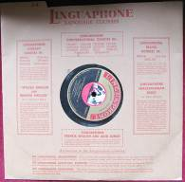 | Oth | SRM
003283 | IRMT/SRM/003283/Oth/ Gramophone record, Linguaphone Language Courses, #7-8/ 003283 | Gramophone record |  |  | Gramophone record, Linguaphone Language Courses 7-8  (Roerichs’s collection) | 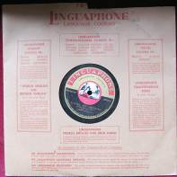 | Oth | SRM
003284 | 003284 | Reproduction |  |  | Reproduction of S.Roerich’s painting | 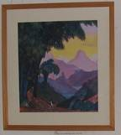 | P | SRM
003285 | 003285 | Reproduction |  |  | Reproduction of S.Roerich’s painting | 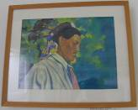 | P | SRM
003286 | 003286 | Reproduction |  |  | Reproduction of S.Roerich’s painting | 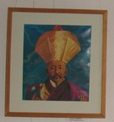 | P | SRM
003287 | 003287 | Reproduction |  |  | Reproduction of S.Roerich’s painting | 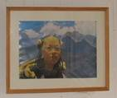 | P | SRM
003288 | 003288 | Reproduction |  |  | Reproduction of S.Roerich’s painting | 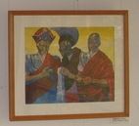 | P | SRM
003289 | 003289 | Reproduction |  |  | Photo of Svetoslav Roerich (copy) | 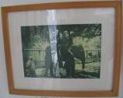 | Ph | SRM
003290 | 003290 | Reproduction |  |  | Photo of Svetoslav Roerich (copy) | 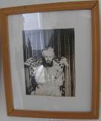 | Ph | SRM
003291 | 003291 | Reproduction |  |  | Photo of Svetoslav Soerich (copy) | 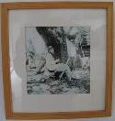 | Ph | SRM
003292 | 003292 | Reproduction |  |  | Photo (copy) | 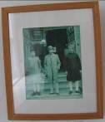 | Ph | SRM
003293 | 003293 | Reproduction |  |  | Photo of Svetoslav Roerich (copy) | 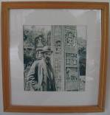 | Ph | SRM
003294 | 003294 | Reproduction |  |  | Photo of Svetoslav Roerich with family, Jawarhalal Nehru, Indira Gandhi (copy) | 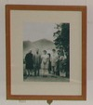 | Ph | SRM
003295 | 003295 | Reproduction |  |  | Photo of Svetoslav Roerich, Nicholas Roerich and Devika Rani Roerich, Naggar 1945 (copy) | 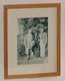 | Ph | SRM
003296 | 003296 | Reproduction |  |  | Photo of Svetoslav Roerich, Devika and George (copy) | 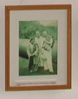 | Ph | SRM
003297 | 003297 | Reproduction |  |  | Photo (copy) | 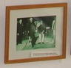 | Ph | SRM
003298 | 003298 | Reproduction |  |  | Photo (copy) | 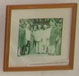 | Ph | SRM
003299 | 003299 | Display table |  |  | Display table  (wood, glass, khadi cloth) | 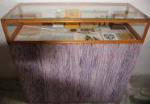 | Pr_F | SRM
003300 | IRMT/SRM/003300/Doc/ card 1967/1968 from Indira Gandhi / 003300 | Card |  |  | Happy New Year card 1967/1968 from Indira Gandhi  to Svetoslav and Devika Rani Roerichs | 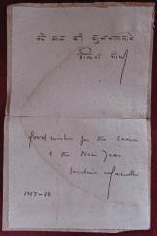 | Doc | SRM
003301 | IRMT/SRM/003301/Doc/ Invitation (29.05.1973) from Indira Gandhi /003301 | Invitation |  |  | Invitation (29.05.1973) from Indira Gandhi to Svetoslav and Devika Rani Roerichs | 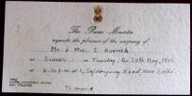 | Doc | SRM
003302 | IRMT/SRM/003302/Doc / Card of Yuri Gagarin  /003302 | Card |  |  | Card of Yuri Gagarin with his words & signature to Svetoslav and Devika Rani Roerichs, February 1962, Moscow | 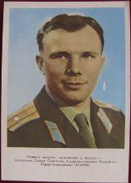  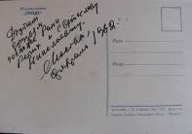 | Doc | SRM
003303 | IRMT/SRM/003303/B/ Book of Agni Yoga “Heart’ in Russian,1934,  #277/ 003303 | Book |  |  | Book of Agni Yoga “Heart’ in Russian (original, from Roerichs’ collection), 10th of April, 1934, Stamp of International Roerich Memorial Trust  # 277 | 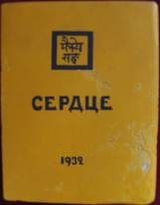 | B | SRM
003304 | IRMT/SRM/003304/Doc/ Letter to Vishnu 1, from 5th of May, 1961  /003304 | Letter |  |  | Letter to Vishnu 1, from 5th of May, 1961 | 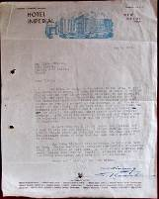 | Doc | SRM
003305 | IRMT/SRM/003305/Doc/ Letter to Vishnu 2, from 25th of May, 1959/003305 | Letter |  |  | Letter to Vishnu 2, from 25th of May, 1959 | 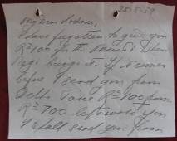  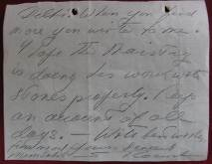 | Doc | SRM
003306 | 003306 | Medal |  |  | Jubilee Medal of S.Roerich  (done by ICR Moscow) | 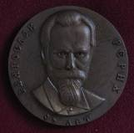 | Oth | SRM
003307 | IRMT/SRM/003307/P/ Sketch by S.Roerich /003307 | Sketch |  |  | Sketch by S.Roerich  (partially damaged)  (ink or water-colors on paper) | 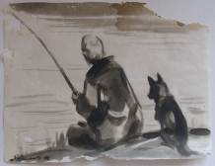 | P | SRM
003308 | IRMT/SRM/003308/B/ Sutton seeds brochure, Season 1946  /003308 | Brochure |  |  | Sutton seeds brochure,  Season 1946 | 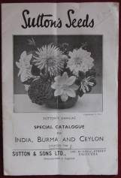 | B | SRM
003309 | IRMT/SRM/003309/Oth/ Box of tempera colors  /003309 |  |  |  | Tempera colors in the cardboard box (S.Roerich’s),  6 pieces, partially damaged | 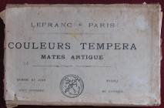  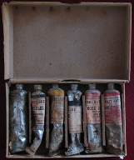 | Oth | SRM
003310 | IRMT/SRM/003310/Oth/ Medium for Oil colors /003310 | Medium |  |  | Medium for Oil colors in green glass bottle, 1 p. | 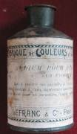 | Oth | SRM
003311 | IRMT/SRM/003311/Bot/ medicinal seeds in bottle/003311 | Bottle |  |  | Bottle 1 with medicinal seeds (from Urusvati collection) | 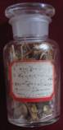 | Bot | SRM
003312 | IRMT/SRM/003312/Bot/ medicinal seeds in bottle 2/ 003312 | Bottle |  |  | Bottle 2 with medicinal seeds (from Urusvati collection) | 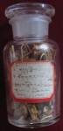 | Bot | SRM
003313 | IRMT/SRM/003313/Doc/ Report card /003313 | Report card |  |  | Report card  (from Urusvati collection) | 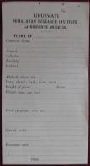 | Doc | SRM
003314 | IRMT/SRM/003314/ Pr_In/ Old wooden clock /003314 | Clocks |  |  | Old wooden clock  Damaged  (Roerichs’ collection)  # 93.549 | 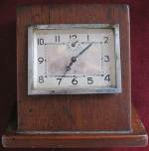 | Pr_In | SRM
003315 | IRMT/SRM/003315/ Pr_El/ Kodak film plates /003315 | Film plates |  |  | Kodak film plates belonging to S.Roerich (2 p., glass)  1933 | 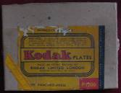  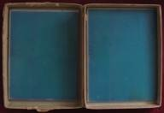 | Pr_El | SRM
003316 | IRMT/SRM/003316/ Pr_F/ wooden table /003316 | Table |  |  | Roerichs’ wooden table with carved legs, worn out surface, square  Size 67,7 x 68,3 x 73,5  # 93.630 | 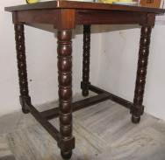 | Pr_F | SRM
003317 | IRMT/SRM/003317/ Pr_S/ Porcelain tea set of ellow color 8 pcs/ 003317 | Tea set |  |  | Tea set (1 tea pot & 4 cups with 3 plates, yellow color, with black handles of fine china, made in Czechoslovakia | 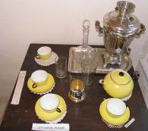 | Pr_S | SRM
003318 | IRMT/SRM/003318/ Pr_S/ 1 glass jar/ 003318 | Glass jar |  |  | 1 glass jar for the water with top  (Roerichs’ collection) | 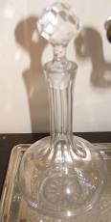 | Pr_S | SRM
003319 | IRMT/SRM/003319/ Pr_S/ 1 glass / 003319 | Glass |  |  | Glass 1  (Roerichs’ collection) | 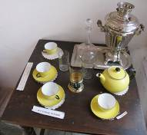 | Pr_S | SRM
003320 | IRMT/SRM/003320/ Pr_S/ 2 glass / 003320 | Glass |  |  | Glass 2  (Roerichs’ collection) | 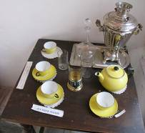 | Pr_S | SRM
003321 | IRMT/SRM/003321/ Pr_S/ Glass with glass holder glass / 003321 | Glass with holder |  |  | Glass with glass holder (metal holder with decorations)  (Roerichs’ collection) | 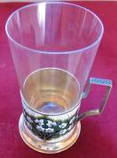 | Pr_S | SRM
003322 | IRMT/SRM/003322/ Pr_S/ ‘Samovar’/ 003322 | Samovar |  |  | Russian ‘Samovar’  (Roerichs’ collection) | 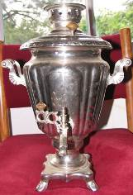 | Pr_S | SRM
003323 | IRMT/SRM/003323/ Pr_S/ Metal tray / 003323 | Tray |  |  | Metal tray  (Roerichs’ collection) | 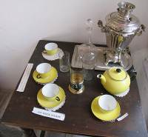 | Pr_S | SRM
003324 | 003324 | Reproduction |  |  | Reproduction of S.Roerich’s painting | 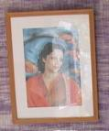 | P | SRM
003325 | 003325 | Reproduction |  |  | Reproduction of S.Roerich’s painting | 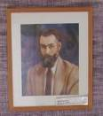 | P | SRM
003326 | 003326 | Reproduction |  |  | Reproduction of S.Roerich’s painting | 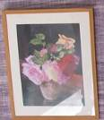 | P | SRM
003327 | 003327 | Reproduction |  |  | Reproduction of S.Roerich’s painting | 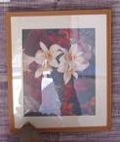 | P | SRM
003328 | 003328 | Reproduction |  |  | Reproduction of S.Roerich’s painting | 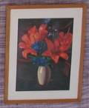 | P | SRM
003329 | 003329 | Photograph |  |  | Photo of Devika Rani (copy) | 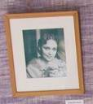 | Ph | SRM
003330 | 003330 | Photograph |  |  | Photograph of Svetoslav Roerich (copy) | 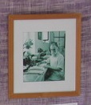 | Ph | SRM
003331 | IRMT/SRM/003331/ Ms/ group of crystals / 003331 | Crystals |  |  | Group of 14 crystals in the wooden stand  (Roerichs’ collection) | 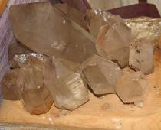 | Ms | SRM
003332 | IRMT/SRM/003332/ Pr_F/ ceramic & metal stove/ 003332 | Stove |  |  | Original ceramic & metal stove  (Roerichs’ collection)  Size 53 x 114,5 x44 cm  # 93.830 | 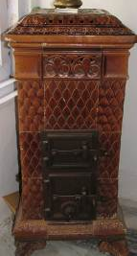 | Pr_F | SRM
003333 | IRMT/SRM/003333/ Pr_El/ lamp with metal frame/ 003333 | Lamp |  |  | Iron Lamp  (Roerichs’ collection)  # 93.250 | 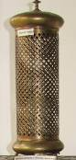 | Pr_El | SRM
003334 | 003334 | Photograph |  |  | Photograph (copy) | 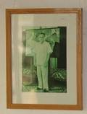 | Ph | SRM
003335 | 003335 | Photograph |  |  | Photograph (copy) | 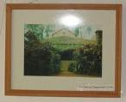 | Ph | SRM
003336 | 003336 | Photograph |  |  | Photograph (copy) | 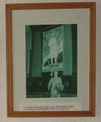 | Ph | SRM
003337 | 003337 | Photograph |  |  | Photograph (copy) | 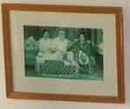 | Ph | SRM
003338 | 003338 | Photograph |  |  | Photograph (copy) | 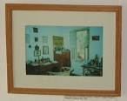 | Ph | SRM
003339 | 003339 | Photograph |  |  | Photograph (copy) | 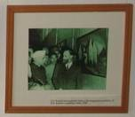 | Ph | SRM
003340 | 003340 | Reproduction |  |  | Reproduction of S.Roerich’s painting | 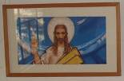 | P | SRM
003341 | 003341 | Reproduction |  |  | Reproduction of S.Roerich’s painting | 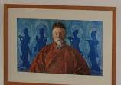 | P | SRM
003342 | 003342 | Photograph |  |  | Photograph (copy) | 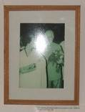 | Ph | SRM
003343 | 003343 | Photograph |  |  | Photograph (copy) | 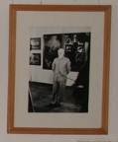 | Ph | SRM
003344 | 003344 | Photograph |  |  | Photograph (copy) | 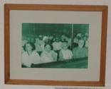 | Ph | SRM
003345 | 003345 | Photograph |  |  | Photograph (copy) | 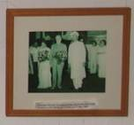 | Ph | SRM
003346 | IRMT/SRM/003346/ Pr_Cl/ Devika Rani’s  fur shoes / 003346 | Shoes |  |  | Devika Rani’s  fur shoes  (partially damaged) | 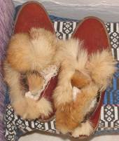 | Pr_Cl | SRM
003347 | 003347 | Display table |  |  | Display table with personal belongings of Devika Rani (wood, glass, khadi cloth) | 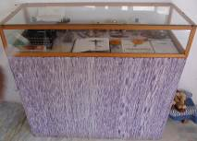 | Pr_F | SRM
003348 | IRMT/SRM/003348/ Pr_El/ Typing machine “Corona” with a letter to Vishnu /003348 | Typing machine |  |  | Typing machine “Corona” with a letter to Vishnu  (Roerichs’ collection) | 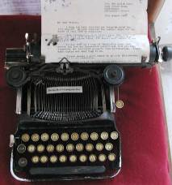 | Pe_El | SRM
003349 | IRMT/SRM/003349/ Pr_El/ Sealing wax /0803349 | Sealing wax |  |  | Sealing wax in cardboard box (4 p. full and 4 p. broken)  (Roerichs’ collection) | 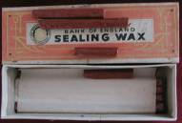 | Pr_El | SRM
003350 | IRMT/SRM/003350/ Pr_El/ Iron stapler /003350 | Iron stapler |  |  | Iron stapler “10 Toys J. Co, Ltd”  (Roerichs’ collection) | 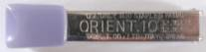 | Pr_El | SRM
003351 | IRMT/SRM/003351/ B/ Bible of Devika Rani’s mother /003351 | Bible |  |  | Bible of Devika Rani’s mother presented by her to Devika, with dedicatory inscription  Some pages damaged by silver fish | 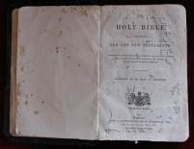  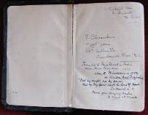 | B | SRM
003352 | IRMT/SRM/003352/ Pr/ Cross of Devika Rani /003352 | Cross |  |  | Cross of Devika Rani  No 93.222 (?)  (Devika Rani’s collection) | 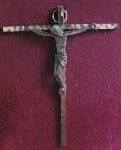 | Pr | SRM
003353 | IRMT/SRM/003353/ Pr/ Perfume bottle “Le Tigre” / 003353 | Perfume bottle |  |  | Perfume bottle “Le Tigre”  (Devika Rani’s collection) | 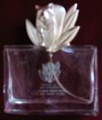 | Pr | SRM
003354 | IRMT/SRM/003354/ Pr/ Perfume bottle “Tata’s Eau de Cologne”/ 003354 | Perfume bottle |  |  | Perfume bottle “Tata’s Eau de Cologne”  (Devika Rani’s collection) | 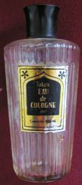 | Pr | SRM
003355 | IRMT/SRM/003355/ In/fabic  /003355 | Samples of fabric |  |  | Samples of cloth fabric (3 p.)  (Devika Rani’s collection) | 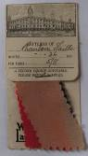  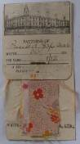  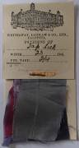 | In | SRM
003356 | IRMT/SRM/003356/ In/ Khokhloma’ colored box  /003356 | Box |  |  | Russian wooden ‘Khokhloma’ colored box  (Devika Rani’s collection) | 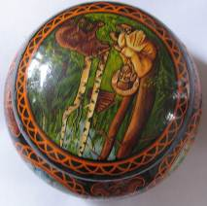 | In | SRM
003357 | IRMT/SRM/003357/ Pr/ Devika Rani’s amber necklaces (2 p. + 1 broken string)  /003357 | Necklaces |  |  | Devika Rani’s amber necklaces (2 p. + 1 broken string) | 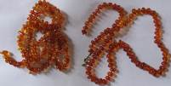  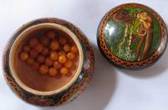 | Pr | SRM
003358 | IRMT/SRM/003358/ Pr_El/  Cards for orchard fruit boxes 9 pcs  /003358 | Cards |  |  | Cards for Roerich orchard fruit boxes (9 p.) | 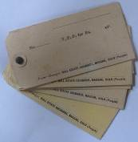 | Pr_El | SRM
003359 | IRMT/SRM/003359/ Doc/  Letter from 27 of June, 1961/003359 | Letter |  |  | Letter from 27 of June, 1961 | 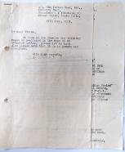 | Doc | SRM
003360 | IRMT/SRM/003360/ Doc/  Letter dd 16 of May 1961 /003360 | Letter |  |  | Letter from 16 of May, 1961 | 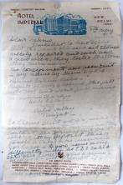 | Doc | SRM
003361 | IRMT/SRM/003361/ Ms/  Crystal #93.153/003361 | Crystal |  |  | Crystal  (Roerichs’ collection)  # 93.153 | 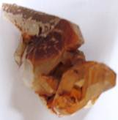 | Ms | SRM
003362 | IRMT/SRM/003362/ Pr_El/  Glass stand for pens/003362 | Glass stand |  |  | Glass stand for pens with 3 ball bar and 1 ink bar  (Roerichs’ collection)  # 93.189 (?) | 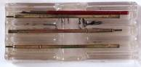  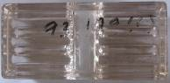 | Pr_El | SRM
003363 | IRMT/SRM/003363/ Pr_El /  Corrective fluid “Pelican”, /003363 | Corrective fluid |  |  | Corrective fluid “Pelican”, glass bottle, 30 ml  (Roerichs’ collection) | 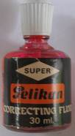 | Pr_El | SRM
003364 | IRMT/SRM/003364/ Pr_El/  Nail Polish /003364 | Nail Polish |  |  | Nail Polish (Rose color)  (Devika Rani’s collection) | 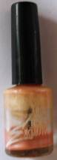 | Pr_El | SRM
003365 | IRMT/SRM/003365/ Pr_El/ Eye pensil/003365 | Eye pencil |  |  | Eye pencil (green cover, black)  (Devika Rani’s collection) | 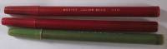 | Pr_El | SRM
003366 | IRMT/SRM/003366/ Pr_El/ lip pensil/003366 | Lips pencils |  |  | Lips pencils (2 p.)  (Devika Rani’s collection) | 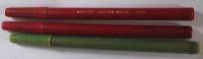 | Pr_El | SRM
003367 | IRMT/SRM/003367/ Pr_F/  S.Roerich’s easel/003367 | Easel |  |  | S.Roerich’s easel  Size 50 x 1,90 cm | 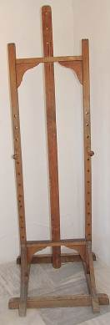 | Pr_F | SRM
003368 |  | Reproduction |  |  | Reproduction of Svetoslav Roerich’s painting of Devika Rani Roerich”, 1946  Size 121,1 x 91 cm | 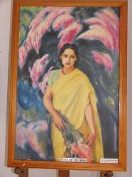 | P | SRM
003369 |  | Photograph |  |  | Photograph (copy) |  | Ph | SRM
003370 |  | Photograph |  |  | Photograph (copy) |  | Ph | SRM
003371 |  | Photograph |  |  | Photograph (copy) |  | Ph | SRM
003372 |  | Photograph |  |  | Photograph (copy) |  | Ph | SRM
003373 |  | Photograph |  |  | Photograph (copy) |  | Ph | SRM
003374 |  | Photograph |  |  | Photograph (copy) |  | Ph | SRM
003375 |  | Photograph |  |  | Photograph (copy) |  | Ph | SRM
003376 |  | Photograph |  |  | Photograph (copy) |  | Ph | SRM
003377 |  | Banner |  |  | Banner of Peace on the ceiling |  | Oth | SRM
003378 |  | Flags |  |  | Indian & Russian National flags | 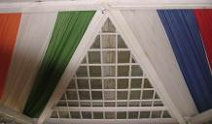 | Oth | SRM
003379 | IRMT/UR/003379/B/ Bulletin of … Indiana University, Vol. XXX, Nos 5 and 6, Sept and Nov 1954/003379 | Book |  |  | Bulletin of the School of education , Indiana University, Vol. XXX, Nos 5 and 6, Sept. and Nov. 1954, Indiana and Midwest School Building Planning Conference proceedings 121 p. |  | B | UR
003380 | IRMT/UR/003380/B/ Transactions… of the Botanical Society of Pennsylvania, sessions 1904 -1909, vol..II 1911, No.1/ 003380 | Book |  |  | Transactions and Proceedings of the Botanical Society of Pennsylvania, sessions 1904 -1909, Vol. II 1911, No.1  University of Penns, Philadelphia, 1911,  427 p. + Annexes,  Urusvati Stamp |  | B | UR
003381 | IRMT/UR/003381/J/ Journal of then Elisha Mitchel Scientific Aug 1935, No.1 Vol. 51 Society /003381 | Book |  |  | Journal of then Elisha Mitchel Scientific Society, Aug. 1935, No.1 Vol. 51, Chapel Hill, N.C., USA, 190 p. + plates |  | B | UR
003382 | IRMT/UR/003382/B/ The Root Habits of Desert plants by William Austin /003382 | Book |  |  | The Root Habits of Desert plants by William Austin Cannon, Washington D.C. 191, Urusvati stamp |  | B
003383 | IRMT/UR/003383/B/ The Water balance of… by D.T. Macdougal …/003383 | Book |  |  | The Water balance of Succulent Plants by D.T. Macdougal and E.S. Splading Washington D.C. 1910, 77 p., Urusvati stamp |  | B
003384 | IRMT/UR/003384/B/ Studies in Plant respiration … by H.A. Spoehr…/003384 | Book |  |  | Studies in Plant respiration and Photosynthesis by H.A. Spoehr and J.M.McGee published by Carnegie Institute of Washington, W Washington D.C.1 911  Urusvati stamp ashinton, February, 1923, 98 p.  Damaged cover |  | B
003385 | IRMT/UR/003385/B/ Konrad L.Noack, Grunzuge der Botanik/ 003385 | Book |  |  | Konrad L.Noack, Grunzuge der Botanik 1929, Verlag von Ferdinand enke in Stuttgart, G.Roerich ex-libris. Piece of paper inserted with words : “To be placed in my library” |  | B
003386 | IRMT/UR/003386/B/ Ocean Magnetic and Electric observations 1915-1921  /003386 | Book |  |  | Ocean Magnetic and Electric observations, 1915-1921, published by Carnegie Institute of Washington, Washington D.C. 1926, 430 p. + 5 plates, Urusvati stamp |  | B
003387 | IRMT/UR/003387/J/ The Visva-Bharaty quarterly Vol.III Part IV, 1938/ 003387 | Book |  |  | The Visva-Bharaty quarterly Vol. III Part IV, 1938 – Apr., 1938, 394 p. |  | B
003388 | IRMT/UR/003388/B/ Ephemerides Orientalistes N 103 – 1929 /003388 | Book |  |  | Ephemerides Orientalistes, № 103 – 1929 November-December, Laibrairie Orientaliste, Paul Geuthner |  | B
003389 | IRMT/UR/003389/B/ Leyden Annual bibliography of Indian Archeology for the year 1931/ 003389 | Book |  |  | Kern Institute – Leyden Annual bibliography of Indian Archeology for the year 1931, Leyden: E.J.brill Ltd – 1933, 210 p., 12 plates, Insertions, note G.Roerich – In exchange |  | B
003390 | IRMT/UR/003390/B/ A Comparative study of temperature By Francis G. Benedict and… /003390 | Book |  |  | A Comparative study of temperature fluctuations in different parts of the human body By Francis G.Benedict and Edgar P.Slack published by Carnegie Institute of Washington, W Washington D.C. 1914 p 74 |  | B
003391 | IRMT/UR/003391/B/ Records of The Geological Survey of India Vo.72, Part 4. 1938/003391 | Book |  |  | Records of The Geological Survey of India Vo.72, Part 4. 1938, 496 p, with Index and a map. |  | B
003392 | IRMT/UR/003392/J/ Archive Oriental Journal of the Czechoslovak Oriental Institute Prague, Vo. VII,1935 / 003392 | Journal |  |  | Archive Oriental Journal of the Czechoslovak Oriental Institute Prague, Vo. VII, Nos 1-2, April-August 1935 dedicated to the (International Congress of Orientalists, Rome  276 p., Urusvati stamp |  | J
003393 | IRMT/UR/003393/J/ Indian Culture, 1935 /003393 | Journal |  |  | Indian Culture ( Journal o the Indian Research Institute), 1935 published by SATIS CHANDRA SEAL, Calcutta  Urusvati Stamp, 188 p |  | J
003394 | IRMT/UR/003394/J/ Journal of the American Oriental Society vol.59  /003394 | Journal |  |  | Journal of the American Oriental Society vol.59, No1. March 1939, 137 p. |  | J
003395 | IRMT/UR/003395/Pr_F/ Square table / 003395 | Table |  |  | Square table, Dark wood,  Surface : spots, worn out,  Size 135 x 120  #93.787 |  | Pr_F | UR
003396 | IRMT/UR/003396/Pr_F/ Two parts Bookcase/  003396 | Bookcase |  |  | Two parts Bookcase, Brown wood, 6 shelves in each;  Doors each glazed with glass, Condition: satisfactory  Size 186 x 216,5 x 29 cm  #93.753 |  | Pr_F | UR
003397 | IRMT/UR/003397/Pr_F/ Deep square bookcase  /003397 | Bookcase |  |  | Deep square bookcase, Light brown,  Condition: satisfactory  Size 95,5 x 96,5 x 127 cm |  | Pr_F | UR
003398 | IRMT/UR/003398/ Pr_F/ Three parts bookcase /003398 | Bookcase |  |  | Three parts bookcase, each part is divided into two parts with five shelves each, Condition: satisfactory,  Size 180 x 218 x 52 cm |  | Pr_F | UR
003399 | IRMT/UR/003399/Pr_F/ Three parts bookcase /003399 | Bookcase |  |  | Three parts bookcase, each part is divided into two parts with five shelves each, Condition: satisfactory  Size 180 x 218 x 52 cm |  | Pr_F | UR
003400 | IRMT/UR/003400/Pr_F/ Three parts bookcase /003400 | Bookcase |  |  | Three parts bookcase, each part is divided into two parts with five shelves each, Condition: satisfactory  Size 180 x 218 x 52 cm |  | Pr_F | UR
003401 | IRMT/UR/0033401/Pr_F/ Deep square bookcase  /003401 | Bookcase |  |  | Deep square bookcase, Light brown  Condition: satisfactory  Size 66 x 170,5 x 166 cm |  | Pr_F | UR
003402 | IRMT/UR/003402/B/ Subscription form for Tibetan-English Dictionary by George de ROERICH/  003402 | Dictionary |  |  | Tibetan-English Dictionary by George de Roerich in collaboration with Lama Lobzang Mingyur Dorje, Subscription form ( to be issued in the course of 1934) |  | B | UR
003403 | IRMT/UR/003400/Pr_F/ Wooden filing cabinet /003403 | Cabinet |  |  | Wooden filing cabinet, 6 drawers with wooden handles, Material: wood  Condition: worn out surface  Size 41 x 60,5 x 31 cm |  | Pr_F | UR
003404 | IRMT/HE_3/003404/ B/ Columbia University Bulletin of Information1920-1921/003404 | Book |  |  | Columbia University Bulletin of Information. Division of Ancient and Oriental languages, Announcement 1920-1921, 26 p., With hand written name G. Roerich and marks by G. Roerich |  | B | HE_3
003405 | IRMT/HE_3/003405/ B/ Exhibition of Masters of French 19th Century Paintings 1936/003405 | Book |  |  | Exhibition of Masters of French 19th Century Paintings 1936, Anglo-French Art Travel Society, 56 p + paintings reproductions  With numerous notes by N. Roerich |  | B | HE_3
003406 | IRMT/ HE_U3/ 003406/Et/ Unidentified piece made of leather and wood 93.510  /003406 | Unidentified piece |  |  | Unidentified piece made of leather and wood with stripes, leather painted black and red with brass rivets, Condition: dried leather, faded colors, accumulated dust.  (Roerichs’ collection)  Size 48 x 21 cm  #93.510 | 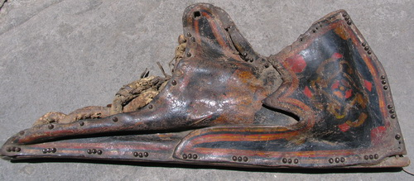  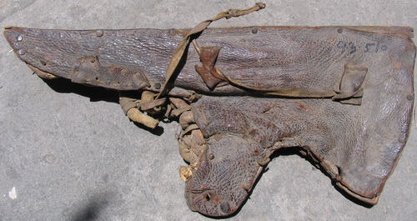 | Et | HE_U3
003407 | IRMT/ HE_D1/ 003407/Oth/ Stationary and others  / 003407 | Stationary and others  Black covers from Financial docs Imperial bank of India |  |  | Stationary and others  Black covers from Financial docs Imperial bank of India, 3 pcs, Yellow ABC File dividers from east-light Arcel and Bobinel Files made in England , 24 x 19 cm 2 p., Yellow Pages divided into 4 parts for registration – 3 lists  (Roerichs’ collection) |  | Oth | HE_D1
003408 | IRMT/ HE_D1/ 003408/Pr_El/ Pocket London Filter /003408 | Pocket London Filter |  |  | Pocket London Filter, black round disk with a label and coal filter inside, Label reads The Atkins Filter engineering & Water softening company  Size 10 x 3,5 cm  (Roerichs’ collection) | 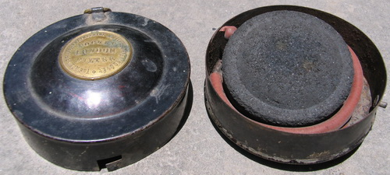 | Pr_El | HE_D1
003409 | IRMT/ HE_D1/ 003409/Oth/ Strip of canvas /003409 | Strip of canvas |  |  | Strip of canvas, coated  Size 129 x 12 cm  (Roerichs’ collection) |  | Oth | HE_D1
003410 | IRMT/ HE_D1/ 003410/Oth/ Couleurs Tempera /003410 | Colors |  |  | Couleurs TEMPERA Mate Atigue in a cardboard box, remains of label: Lefranc Paris, five tubes, Tubes Damaged  (Roerichs’ collection)  Size 13,2 x 9 cm | 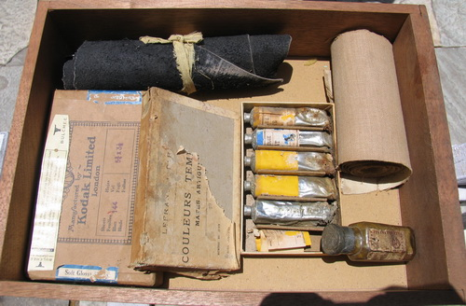 | Oth | HE_D1
003411 | IRMT/ HE_D1/ 003411/Oth/ Or Riche Brillait 003411 | Bottle |  |  | Bottle with faded label  Or Riche Brillait, Lefranc Paris, Sealed  (Roerichs’ collection) |  | Oth | HE_D1
003412 | IRMT/ HE_D1/ 003412/Pc/ Post Cards /003412 | Cards of Paintings and nature photos in an envelope |  |  | Cards of Paintings and nature photos in an envelope  - Samarkand 3 p. with notes of sender  - The Repin Penate  - Photos of lakes  - Lithuania, Latvia  - Russian Churches  - Reproductions of paintings |  | Pc | HE_D1
003413 | IRMT/ HE_D1/ 003413/Pc/ Card of painting of Cosaque /003413 | Card of painting |  |  | Card of painting of Cosaque, Inscription: Armee Russe- Cosaques de Sa Majeste - 1914 |  | Pc | HE_D1
003414 | IRMT/UR/003400/Pr_F/ | Banner |  |  | Banner of Peace on the wall |  | Pr_F | UR
003415 | IRMT/UR/003400/Pr_F/003415 | Write-up |  |  | Write-up on Urusvati Institute | 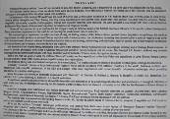 | Doc | UR
003416 | IRMT/UR/003416/Z/ Box with the stuffed birds (8 p.) and small mammals (3 p /003416 | Box with the stuffed birds |  |  | Box with the stuffed birds  (8 p.)  and small mammals (3 p.),  (Roerichs’ collection)  Size of the box 50 x 48 cm | 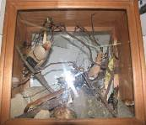 | Z | UR
003417 | IRMT/UR/003417/Pr/ Roerichs’ expedition box with used bullets /003417 | Expedition box |  |  | Roerichs’ expedition box with used bullets (S.N. 62)  Size of the box 48 x 22,5 cm | 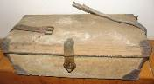  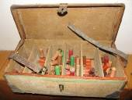 | Pr | UR
003418 | IRMT/UR/003418/Pr_El/ iron fan /003418 | Iron fan |  |  | Roerichs’ iron fan  Size 56 x 92 cm | 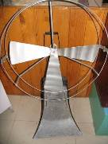 | Pr_el | UR
003419 | IRMT/UR/003419/Pr_F/ wooden bookcase /003419 | Wooden bookcase |  |  | Roerichs’ wooden bookcase  (4 shelves)  Size 136,5 x 118 x 29 cm  #93.764 | 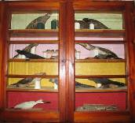 | Pr_F | UR
003420 | IRMT/UR/0034200/Z/ Stuffed birds (26 p.)  /003420 | Stuffed birds |  |  | Stuffed birds (26 p.) in a wooden cupboard  1st shelf: 4 big birds  2nd shelf: 5 big, 8 small birds  3rd shelf: 4 big birds  4th shelf: 3 big, 2 small birds  (Roerichs’ collection) | 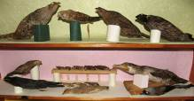  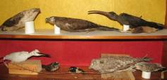 | Z | UR
003421 | IRMT/UR/003421/ S ut / Brass scientific bottle /003421 | Brass scientific bottle |  |  | Brass scientific bottle (small),  Diameter 7 cm, height 19 cm  (Roerichs’ collection) | 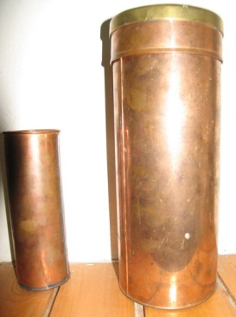 | S ut | UR
003422 | IRMT/UR/003422/ S ut / Two piece brass scientific bottle /003422 | Brass scientific bottle |  |  | Brass scientific bottle in two pieces (big)  Diameter 12 cm, height 31 cm  (Roerichs’ collection) |  | S ut | UR
003423 | IRMT/UR/003423/Pr/ expedition trunk /003423 | Expedition trunk |  |  | Roerichs’ expedition trunk, wood, leather on the top.  Inside botanical herbarium’s lists.  (Roerichs’ collection)  Size 77 x 41 x 33 cm | 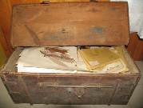  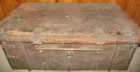 | Pr | UR
003424 | IRMT/UR/003424/ S ut / Display panel with herbarium lists, 3 ps./003424 | Display panel |  |  | Display panel with herbarium lists (3 sheets of herbarium) | 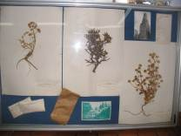 | S ut | UR
003425 | IRMT/UR/003425/ Lab / Metallic box /003425 | Scientific equipment |  |  | Scientific equipment from the Urusvati Institute  Metallic box (yellow-red)  (Roerichs’ collection),  Size 30 x 40 x 8,5 cm | 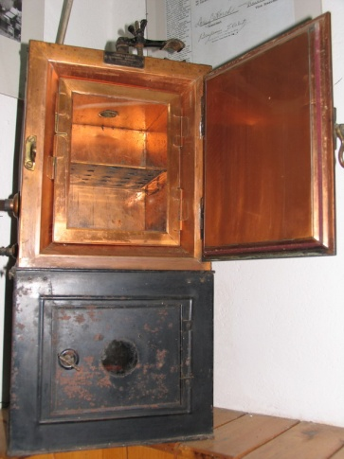 | Lab | UR
003426 | IRMT/UR/003426/ Lab / Metallic box /003426 | Scientific equipment |  |  | Scientific equipment from the Urusvati Institute  Metallic box (black)  (Roerichs’ collection)  Size 28 x 58 x 27 cm |  | Lab | UR
003427 | IRMT/UR/003427/ Lab / Iron Stand with 4 holders /003427 | Stand |  |  | Iron Stand with 4 holders  Scientific equipment from the Urusvati Institute  (Roerichs’ collection)  Height – 96 cm | 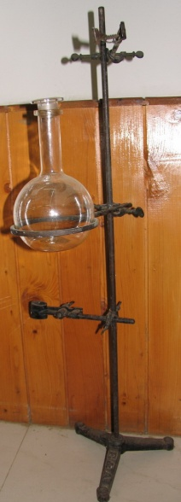 | Lab | UR
003428 | IRMT/UR/003428/ Lab / Glass retord/003428 | Retort |  |  | Glass retort  Scientific equipment from the Urusvati Institute  (Roerichs’ collection)),  Diameter – 12 cm, height – 23 cm |  | Lab | UR
003429 | IRMT/UR/003429/ Lab / Metal vessel with cover /003429 | Vessel |  |  | Metal vessel with cover, having round opening in the centre  (Roerichs’ collection)  Diameter – 34,5 cm, height – 17 cm | 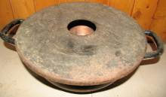 | Lab | UR
003430 | IRMT/UR/003430/ El / 2 glass photo plates / 003430 | Photo plates |  |  | 2 glass photo plates with a letter By N. Roerich  Size: 20 x 25 cm | 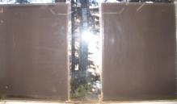 | El | UR
003431 | IRMT/UR/003431/ Lab / Glass funnel /003431 | Funnel |  |  | Glass funnel  (Roerichs’ collection)  Size 18,2 x 22 cm | 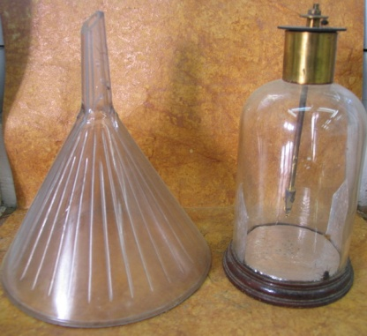 | Lab | UR
003432 | IRMT/UR/003432/ Lab / Glass bottle /003432 | Bottle |  |  | Glass bottle  (Roerichs’ collection)  Size 11 x 22 cm |  | Lab | UR
003433 | IRMT/UR/003433/ Pr_F / filing cabinet /003433 | Cabinet with cards |  |  | G. Roerich’s filing cabinet for linguistic cards (Tibetan language), four boxes inside, with wooden handles  Size 34 x 23 x 51,5 cm | 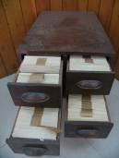 | Pr_F | UR
003434 | IRMT/UR/003434/ Oth / cardboard files 3 pcs /003434 | Cardboard files |  |  | Roerichs’ cardboard files  (3 p.)  Size: 27,5 x 30,5 | 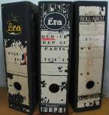 | Oth | UR
003435 | IRMT/UR/003435/ Lab / Barnstead Still Sterilizer /003435 | Sterilizer |  |  | Barnstead Still Sterilizer in two pieces  (Roerichs’ collection)  Sizes: 1st – 20 x 58 cm,  2nd – 15 x 41 cm | 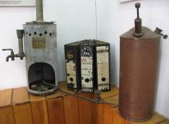 | Lab | UR
003436 | IRMT/UR/003436/ Lab / Burner /003436 | Burners |  |  | Burner (4 parts) – from the Urusvati scientific equipments collection,  Size 11 x 41 x 9,5 cm  #93.529 | 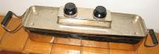 | Lab | UR
003437 | IRMT/UR/003436/ Lab / Oil grinder /003437 | Oil grinder |  |  | Oil grinder (wood & metal)  Size 22 x 19 cm | 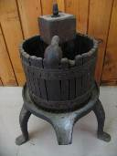 | Lab | UR
003438 | IRMT/UR/003438/ Ms / Mineralogical collection /003438 | Mineralogical collection |  |  | Roerichs’ Mineralogical collection in the wooden box (77 partitions)  Size 84 x 51 x 6 cm | 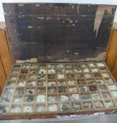 | Ms | UR
003439 | IRMT/UR/003439/ Lab / Surgical sterilizer /003439 | Sterilizer |  |  | Surgical sterilizer  (Roerichs’ collection)  Size 32 x 30 cm  #93.534 | 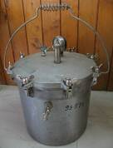 | Lab | UR
003440 | IRMT/UR/003440/ F / Display table in 2 parts /003440 | Display table |  |  | Display table in 2 parts:  (Urusvati Birds collection)  (40 stuffed birds, 1 egg, 1 crystal) | 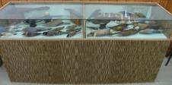 | F | UR
003441 | IRMT/UR/003441/ Lab / Metal oil extractor/ 003441 | Oil extractor |  |  | Metal oil extractor  (Roerichs’ collection)  Size 19 x 51 cm | 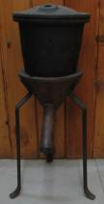 | Lab | UR
003442 | IRMT/UR/003442/ Lab / Oil heater /003442 | Oil heater |  |  | Oil heater  (Roerichs’ collection)  Size 18 x 46 cm | 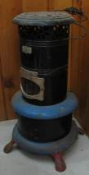 | Lab | UR
003443 | IRMT/UR/003443/ Med/ Local anesthetic /003443 | Anesthetic |  |  | Roerich’s medicinal equipment: Local anesthetic, (green boxes), 2 pcs  Size 12 x 6,7 cm | 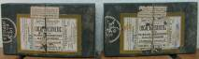 | Med | UR
003444 | IRMT/UR/003444/ Lab/ ceramic ball /003444 | Bowl |  |  | White ceramic bowl  Size 17 x 8 cm | 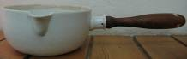 | Lab | UR
003445 | IRMT/UR/003445/ Lab/ ceramic container /003445 | container |  |  | White ceramic container with iron fixer  Size 12x 14 cm | 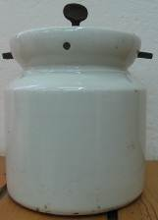 | Lab | UR
003446 | IRMT/UR/003446/ Lab/ Glass plates in carboard box /003446 | Glass plates |  |  | Glass plates (monochrome) in cardboard box ( 5 pcs)  Size 8,5 x 10 cm |  | Lab | UR
003447 | IRMT/UR/003447/ Lab/ Glass bottle with Acide Formique Pure/  003447 | Bottle with acid |  |  | Glass bottle with “Acide Formique Pure”  Size 8 x 18 cm | 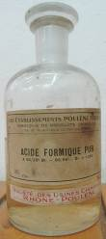 | Lab | UR
003448 | IRMT/UR/003448/ Med/ Surgical scalpels 3 pcs /003448 | Scalpels |  |  | Surgical scalpels 3 pcs  Size 15,15, 19 cm | 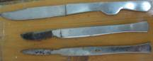 | Med | UR
003449 | IRMT/UR/003449/ Med/ pair of surgical scissors /003449 | Scissors |  |  | One pair of surgical scissors  Size 22 cm | 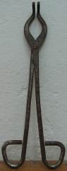 | Med | UR
003450 | IRMT/UR/003450/ Med/ rubber gloves /003450 | Gloves |  |  | One pair of dark brown rubber gloves | 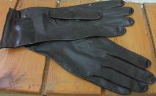 | Med | UR
003451 | IRMT/UR/003451/ Lab/ Round glass plate /003451 |  |  |  | Round glass plate | 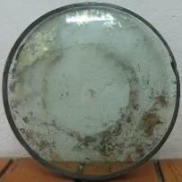 | Lab | UR
003452 | IRMT/UR/003452/ Med/ Medical instruments/ 003452 |  |  |  | Medical instruments  Plastic And Metal  #93.53 | 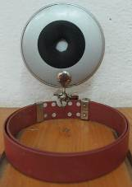 | Med | UR
003453 | IRMT/UR/003453/ Med/ Medical instruments, 5 pcs /003453 |  |  |  | Medical instruments, 5 p. | 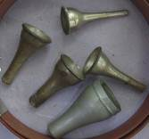 | Med | UR
003454 | IRMT/UR/003454/ Med/ rubber pipe with a funnel /003454 |  |  |  | Rubber pipe with a funnel, orange | 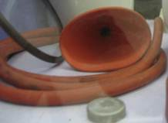 | Med | UR
003455 | IRMT/UR/003455/ Med/ Medical jars 3 pcs/003455 |  |  |  | Medical ceramic jars 3 pcs  (Roerichs’ collection)  One big – #93.504(ii)  Small - #93.505 (iii)  Small - #93/505(ii) |  | Med | UR
003456 | IRMT/UR/003456/ B/ Bulletin of the neurological institute of New-York /003456 |  |  |  | Bulletin of the neurological institute of New-York, December 1938, 336 p. |  | B | UR
003457 | IRMT/UR/003457/ Ms/ Crystal / 003457 |  |  |  | Crystal, clouded  Size 14 x 6,5 cm  #93.287 | 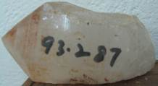 | Ms | UR
003458 | IRMT/UR/003457/ Ms/ Crystal / 003458 |  |  |  | Crystal, nontransparent  Size 9 x 8,5 cm  #93.395 | 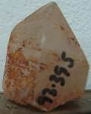 | Ms | UR
003459 | IRMT/UR/003459/ Ms/ Crystal / 003459 |  |  |  | Crystal, with clouds  Size 12 x 8,5 cm  #93.405 |  | Ms | UR
003460 | IRMT/UR/003460/ Ms/ Crystal/ 003460/ |  |  |  | Crystal, semi-transparent  Size 15 x 11,5 cm  #93.324 |  | Ms | UR
003461 | IRMT/UR/003461/ B/ Journal of Urusvati, Himalayan Research Institute, vol.III, 1933/003461 |  |  |  | Journal of Urusvati, Himalayan Research Institute, vol. III, 1933, 231p |  | B | UR
003462 | IRMT/UR/003462/ B/ Abhisamayalamkar’Aloka…/003462 |  |  |  | Abhisamayalamkar’Aloka Praynapara – Mitavyakhya, th work of Haribhadra, The toyo bunko, 1934, 527 p. |  | B | UR
003463 | IRMT/UR/003463/ B/ Bullletin de la Societe de Linguistique de Paris, 1928 /003463 |  |  |  | Bullletin de la Societe de Linguistique de Paris, 1928, 79 p. |  | B | UR
003464 | IRMT/UR/003464/ B/ L’ethnographie, Bulletin de Mesriel /003464 |  |  |  | L’ethnographie, Bulletin de Mesriel, Table des Nos 1 a 24 ( 1913-1931), 289 p. |  | B | UR
003465 | IRMT/UR/003465/ M/ Notes- On History of Persia in G. Roerich handwriting /003465 |  |  |  | George Roerich’s note book: Notes on History of Persia, April 1920 in G. Roerich handwriting  Size 16,5 x 22,5 cm | 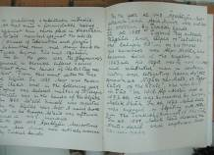 | M | UR
003466 | IRMT/UR/003466/ M/ Notes in G. Roerich handwriting /003466 |  |  |  | Small George Roerich’s note book ( dairy notes) in  G. Roerich handwriting  Size 9 x 14,5 cm | 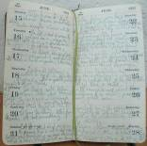 | M | UR
003466_1 | IRMT/UR/003466_1/ Oth/ printing block /003466_1 |  |  |  | Printing block - Photo of Urusvati Institute  Metal and wood  Size 14,5 x 9,5 cm | 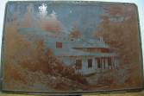 | Oth | UR
003467 | IRMT/UR/003467 /Et/ Tsam mystery mask/003467 |  |  |  | Tsam mystery mask  (Buddhism) | 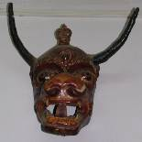 | Et | UR
003468 |  |  |  |  | 19 photos of George Roerich and his paintings (in frames; different sizes) | 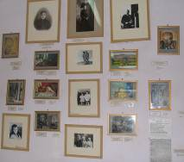 | Ph | UR
003469 |  |  |  |  | 6 reproductions of G.Roerich’s childhood paintings (framed) | 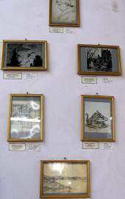 | P | UR
003470 | IRMT/UR/003470 /Et/Wooden carved object /003470 |  |  |  | Wooden carved object  (Roerichs’ collection)  Size 20 x 85 cm | 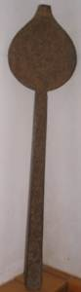 | Et | UR
003471 | IRMT/UR/003471 /Pc/ Photo of George Roerich/003471 |  |  |  | Photo of George Roerich  (in childhood)  in carved wooden frame  Size 13 x 21,5 cm | 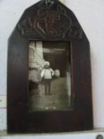 | Pc | UR
003472 | IRMT/UR/003472 /F/ Display table in 3 parts/003472 |  |  |  | Display table in 3 parts:  Part 1: Original photos of G.Roerich and Naggar people  Part 2: Agni Yoga books in different languages; 4 medals of Roerichs; 6 crystals; 3 original Roerichs’ stamps  Part 3: Original Roerichs’ maps; 5 crystals; 3 stamps | 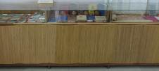 | F | UR
003473 | IRMT/UR/003473 /Doc/ Original Roerichs’ map in roll/ 003473 |  |  |  | Original Roerichs’ map in a roll | 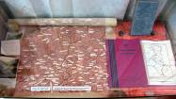 | Doc | UR
003474 | IRMT/UR/003474/ Bot/ Glass jars with herbs seeds/003474 |  |  |  | Glass jars with herbs seeds  (Urusvati collection), 10 p.,  Size 10 x 5 cm | 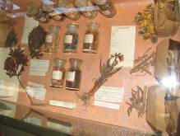 | Bot | UR
003475 | IRMT/UR/003475/ Bot/ Set of cards for labeling: herbarium /003475 |  |  |  | Set of cards for labeling: herbarium of Urusvati Himalayan Research Institute of Roerich museum  Sizes 12,5;6,5;6,7 cm |  | Bot | UR
003476 | IRMT/UR/003476/ Bot /Packs with seeds of medicinal plants, 5 pcs /003476 |  |  |  | Packs with seeds of medicinal plants, 5 pcs  (Roerichs’ collection) |  | Bot | UR
003477 | IRMT/UR/003477/ Ms/ Crystal / 003477 |  |  |  | Crystal 1  (Roerichs’ collection) |  | Ms | UR
003478 | IRMT/UR/003478/ Ms/ Crystal / 003478 |  |  |  | Crystal 2  (Roerichs’ collection) |  | Ms | UR
003479 | IRMT/UR/003479/ Ms/ Crystal / 003479 |  |  |  | Crystal 3  (Roerichs’ collection) |  | Ms | UR
003480 | IRMT/UR/003480/ Ms/ Crystal / 003480 |  |  |  | Crystal 4  (Roerichs’ collection) |  | Ms | UR
003481 | IRMT/UR/003481/ Ms/ Crystal / 003481 |  |  |  | Crystal 5  (Roerichs’ collection) |  | Ms | UR
003482 | IRMT/UR/003482/Oth/ Stamps 3 pcs / 003482 |  |  |  | Stamps 3 p.:  Square stamp – 2 p.  Long stamp – 1 p. |  | Oth | UR
003483 | IRMT/UR/003483/ ExC / Horse saddle/003483 |  |  |  | Horse saddle, ancient (wood, clothes, metal)  (Roerichs’ collection) | 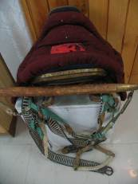 | ExC | UR
003484 | IRMT/UR/003484/ ExC / Horse leather saddle/003484 |  |  |  | Horse leather saddle  (Roerichs’ collection)  Size appr. 56 x 34 cm | 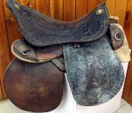 | ExC | UR
003485 | IRMT/UR/003485/ ExC / Open leather double bag/003485 |  |  |  | Open leather double bag (saddle bag)  (Roerichs’ collection)  Size 17 x 26,5 cm | 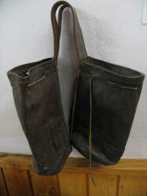 | ExC | UR
003486 | IRMT/UR/003486/ ExC / Leather double bag with covers (saddle bag) /003486 |  |  |  | Leather double bag with covers (saddle bag)  (Roerichs’ collection)  Size 11 x 27,5 cm | 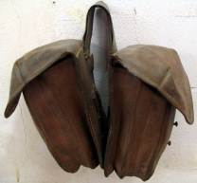 | ExC | UR
003487 | IRMT/UR/003487/ ExC / American expedition flag /003487 |  |  |  | American expedition flag (part) (damaged)  (Roerichs’ collection)  Size 32 x 25 cm | 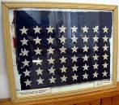 | ExC | UR
003488 | IRMT/UR/003488/ ExC / Small leather bag /003488 |  |  |  | Small leather bag  (Roerichs’ collection)  Size 7,5 x 27,5 cm | 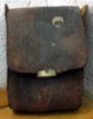 | ExC | UR
003489 | IRMT/UR/003490/Pr_ExC / Cartridge belt of G.Roerich /003489 |  |  |  | Cartridge belt of G.Roerich,  (15 sections)  Size 104 x 11,5 cm  #93.538 | 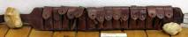 | ExC | UR
003490 |  |  |  |  | 4 reproductions of N.Roerich;  3 photos:  N.Roerich in Mongolia  G.Roerich on horse  H.Roerich and George | 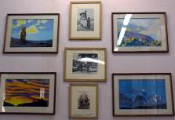 | P | UR
003491 | IRMT/UR/003491/ Ms/ Crystal / 003491 |  |  |  | Crystal  (Roerichs’ collection) | 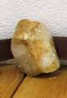 | Ms | UR
003492 | IRMT/UR/003492/ Ms/ Crystal / 003492 |  |  |  | Crystal  (Roerichs’ collection) | 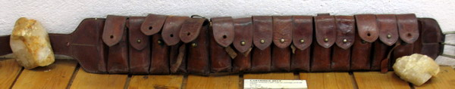 | Ms | UR
003493 |  |  |  |  | 2 reproductions of N.Roerich, 3 photos | 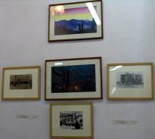 | P | UR
003494 | IRMT/UR/003494/ F/ Display table in 3 parts:/ 003494 |  |  |  | Display table in 3 parts:  - Ancient Chinese coins; 3 crystals, 1 book, 3 brochures;  - Breaking stone ceremony: Urusvati Journal;  - Ancient stones; 1 expedition hammer in leather cover; 3 brochures, 1 photo. | 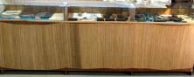 | F | UR
003495 | IRMT/UR/003495/ A/ Ancient Chinese coins collection / 003495 |  |  |  | Ancient Chinese coins collection, 6 pages;  Page1 – 7 pcs  Page2 – 7 pcs  Page3 – 12 pcs  Page4 – 15 pcs  Page5 – 14 pcs  Page6 – 10 pcs  65 pcs  (Roerichs’ collection) | 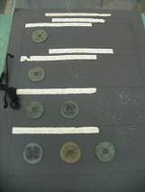 | A | UR
003496 | IRMT/UR/003496/ Ms/ Crystal / 003496 |  |  |  | Crystal  (Roerichs’ collection) |  | Ms | UR
003497 | IRMT/UR/003497/ Ms/ Crystal / 003497 |  |  |  | Crystal  (Roerichs’ collection) |  | Ms | UR
003498 | IRMT/UR/003498/ Ms/ Crystal / 003498 |  |  |  | Crystal  (Roerichs’ collection) |  | Ms | UR
003499 | IRMT/UR/003499/ Ms/ Crystal / 003499 |  |  |  | Crystal  (Roerichs’ collection) |  | Ms | UR
003500 | IRMT/UR/003500/ Oth/ Printing blocks 8 pcs / 003500 |  |  |  | Printing blocks, 8 pcs  (Roerichs’ collection) | 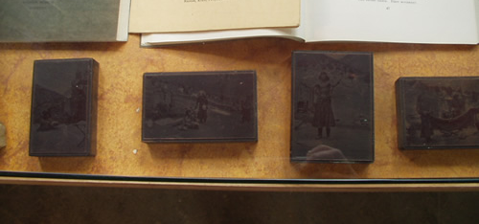 | Oth | UR
003501 | IRMT/UR/003501/ ExC/ expedition hammer in leather cover / 003501 |  |  |  | 1 expedition hammer in leather cover  (Roerichs’ collection) | 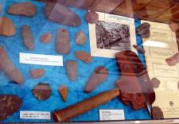 | ExC | UR
003502 | IRMT/UR/003502/ ExC/ Expedition wooden box / 003502 |  |  |  | Expedition wooden box  (Roerichs’ collection)  Size 45 x 28,5 x 21,5 cm | 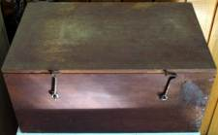 | ExC | UR
003503 | IRMT/UR/003503/ ExC/ Double saddle bag / 003503 |  |  |  | Double saddle bag  (Roerichs’ collection)  Size 26,5 x 46 cm  #93.524 | 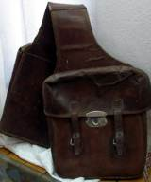 | ExC | UR
003504 |  |  |  |  | 2 photos of George Roerich | 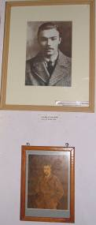 | Ph | UR
003505 | IRMT/UR/003505/ ExC/ Leather horse harness / 003505 |  |  |  | Leather horse harness  (leather and cloth)  (Roerichs’ collection) | 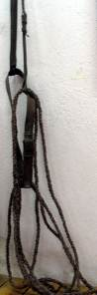 | ExC | UR
003506 | IRMT/UR/003506/ ExC/ Leather horse harness / 003506 |  |  |  | Leather horse harness (leather, cloth, iron)  (Roerichs’ collection) | 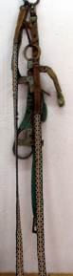 | ExC | UR
003507 | IRMT/UR/003507/ ExC/ Hand leather bag / 003507 |  |  |  | Hand leather bag  (Roerichs’ collection)  Size 26 x 35,5 cm  #93.526 | 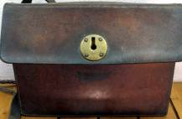 | ExC | UR
003508 |  |  |  |  | N. Roerich - 2 reproductions; photo of G. Roerich | 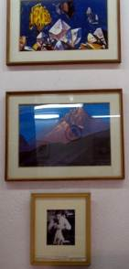 | P | UR
003509 | IRMT/UR/003509/ Ms/ Big crystal , 93.123/ 003509 |  |  |  | Crystal  (Roerichs’ collection)  Size 20,5 x 20 cm  #93.123 | 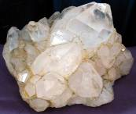 | Ms | UR
003510 | IRMT/UR/003510/ A/ Wooden stand for statue with bronze framing strips / 003510 |  |  |  | Wooden stand for statue with bronze framing strips (statue ‘Krishna with flute’)  Size 58 x 20 x 16 cm  #93.249 | 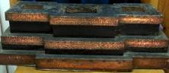 | A | UR
003511 | IRMT/UR/003511/ A/ Big size conshell, carved / 003511 |  |  |  | Big size shell, carved  (Roerichs’ collection)  Size 8,5 x 15,2 cm | 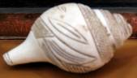 | A | UR
003512 |  |  |  |  | Photo of G. Roerich  on the background of blue cloth | 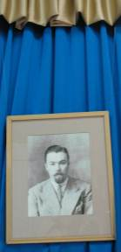 | Ph | UR
003513 |  |  |  |  | 6 photos of George Roerich and family | 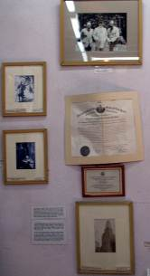 | Ph | UR
003514 | IRMT/UR/003514/ ExC /round map holder / 003514 |  |  |  | Roerichs’ round map holder  (Roerichs’ collection)  Size 11,5 x 93 cm  #93.781 | 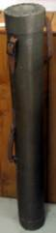 | ExC | UR
003515 |  |  |  |  | 2 reproductions of N.Roerich; 2 photos; | 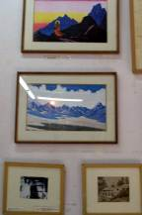 | P | UR
003516 |  |  |  |  | 4 photos of George Roerich and family | 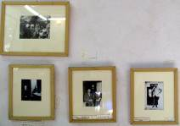 | Ph | UR
003517 | IRMT/UR/003517/ ExC /old map / 003517 |  |  |  | Original old map  (Roerichs’collection) | 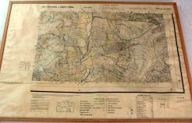 | ExC | UR
003518 | IRMT/UR/003518/ A / Double Vajra painted on wood / 003518 |  |  |  | Double Vajra (wood, painted) on stand  Symbol and private label of the Urusvati Himalayan research Institute  Size 20,5 x 20 cm | 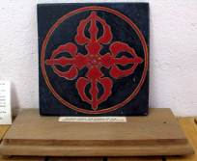 | A | UR
003519 | IRMT/UR/003519/ Oth/ Urusvati Institute plate / 003519 |  |  |  | Urusvati Institute plate (metal)  Size 51 x 30,5 cm | 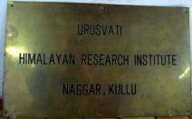 | Oth | UR
003520 | IRMT/UR/003520/ ExC / Green horse harness / 003520 |  |  |  | Green horse harness  leather, iron (brass)  (Roerichs’ collection) | 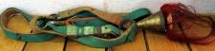 | ExC | UR
003521 | IRMT/UR/003521/ Pr_El / Tennis racket in tying frames and casing, 93.533/ 003521 |  |  |  | Tennis racket in tying frames and casing  (Roerichs’ collection)  Size 23 x 69 cm  #93.533 | 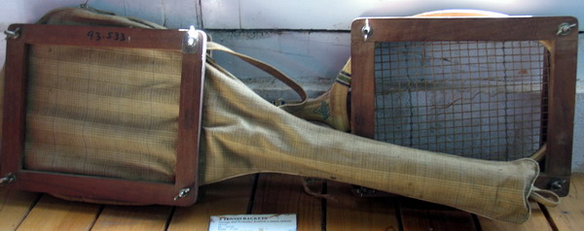 | Pr_El | UR
003522 | IRMT/UR/003522/ Pr_El / Tennis racket in tying frames and casing, 93.532/ 003522 |  |  |  | Tennis racket in tying frames and casing  (Roerichs’ collection)  Size 23 x 69 cm  #93.532 |  | Pr_El | UR
003523 | IRMT/UR/003523/ Pr_El / Roerichs’ oil lamp / 003523 |  |  |  | Roerichs’ oil lamp 1 | 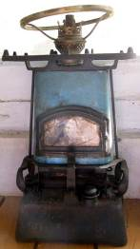 | Pr_El | UR
003524 | IRMT/UR/003524/ Pr_El / Roerichs’ oil lamp / 003524 |  |  |  | Roerichs’ oil lamp 2 | 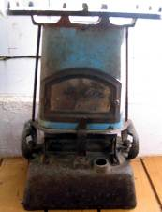 | Pr_El | UR
003525 | IRMT/UR/003525/ F/ Display table in 3 parts:/ 003525 |  |  |  | Display table in 3 parts:  1 part: Books, 2 crystals, ritual wooden hammer, cards;  2 part: Books, G.Roerich’s notebook, 3 crystals, G.Roerich’s linguistic cards  3 part: Journals; 1 crystal, G. Roerich’s cards | 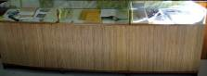 | F | UR
003526 | IRMT/UR/003526/ Ms/ Crystal / 003526 |  |  |  | Crystal  (Roerichs’ collection) |  | Ms | UR
003527 | IRMT/UR/0035279/ Ms/ Crystal / 003527 |  |  |  | Crystal  (Roerichs’ collection) |  | Ms | UR
003528 | IRMT/UR/003528/ Ms/ Crystal / 003528 |  |  |  | Crystal  (Roerichs’ collection) |  | Ms | UR
003529 | IRMT/UR/003529/ Ms/ Crystal / 003529 |  |  |  | Crystal  (Roerichs’ collection) |  | Ms | UR
003530 | IRMT/UR/003530/ Ms/ Crystal / 003530 |  |  |  | Crystal  (Roerichs’ collection) |  | Ms | UR
003531 | IRMT/UR/003531/ Ms/ Crystal / 003531 |  |  |  | Crystal  (Roerichs’ collection) |  | Ms | UR
003532 | IRMT/UR/003532/ExC/ Ritual wooden hammer/003532 |  |  |  | Ritual wooden hammer  (Roerichs’ collection) | 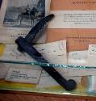 | ExC | UR
003533 | IRMT/UR/003533/Ms/ Crystal /003533 |  |  |  | Crystal  (Roerichs’ collection) |  | Ms | UR
003534 | IRMT/UR/003534/ Ms/ Crystal / 003534 |  |  |  | Crystal  (Roerichs’ collection)  Size 12 x 23 cm | 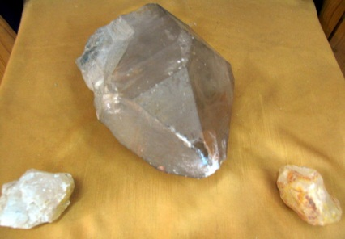 | Ms | UR
003535 | IRMT/UR/003535/ Ms/ Crystal / 003535 |  |  |  | Crystal  (Roerichs’ collection)  Size 7 x 5 cm |  | Ms | UR
003536 | IRMT/UR/003536/ Ms/ Crystal / 003536 |  |  |  | Crystal  (Roerichs’ collection)  Size 7 x 5,5 cm |  | Ms | UR
003537 | IRMT/UR/003537/ Et Bamboo colored basket / 003537 |  |  |  | Bamboo colored basket  (Roerichs’ collection)  Size 12 x 93 cm  #93.511 | 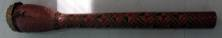 | Et | UR
003538 |  |  |  |  | Banner of Peace;  1 reproductions of N. Roerich; 4 photos | 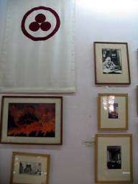 | Ph | UR
003539 |  |  |  |  | 9 photos of George Roerich and family | 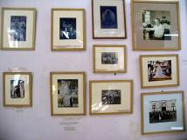 | Ph | UR
003540 |  |  |  |  | Reproduction of N. Roerich;  9 photos of George Roerich; 1 framed write-up | 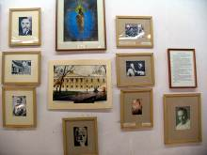 | P | UR
003541 | IRMT/UR/003541/ F/ Display table in 3 parts:/ 003541 |  |  |  | Display table in 3 parts:  Part 1: 2 manuscripts; Book: Blue Annals (2 vol.)  Part 2: Photos & brochures on Pact of Culture  Part 3: 1 dictionary; photo and G. Roerich’s cards in different languages | 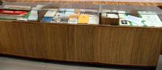 | F | UR
003542 | IRMT/UR/003542/ M/Tibetan manuscript/003542 |  |  |  | Manuscript in Tibetan language, Preliminary Teaching Test  (Roerichs’ collection)  #93.723 | 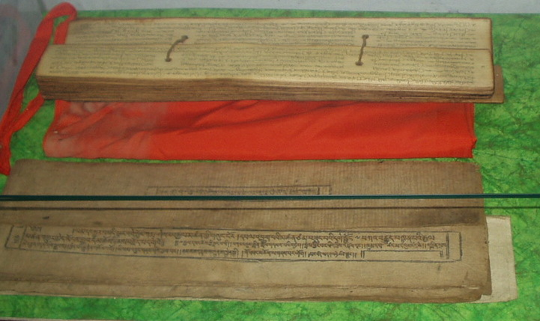 | M | UR
003543 | IRMT/UR/003543/ M/S.Indian manuscript/003543 |  |  |  | Manuscript in South Indian language  # 93.719  (Roerichs’ collection) |  | M | UR
003544 | IRMT/UR/003544/ ExC / Ancient swords in leather sheaths /003544 |  |  |  | Ancient swords in leather sheaths 1  Steel sword, sheath made of wood, covered with leather and grips of iron to hold. Sword has a round blade.  Material: iron  Condition: rusted  (Roerichs’ collection)  Size: blade – 71 cm, Holder – 17 cm, Sheath – 77 cm  # 93.520 | 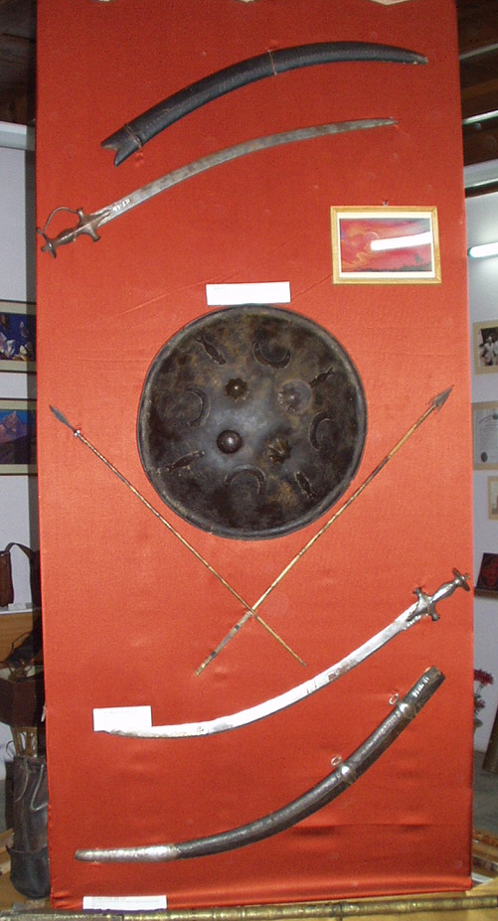 | ExC | UR
003545 | IRMT/UR/003544/ ExC / Ancient swords in leather sheaths/003545 |  |  |  | Ancient swords in leather sheaths 2  Iron made sword, plain curved handle.  Material: iron  Condition: rusted  (Roerichs’ collection)  Size blade – 71 cm, Hanger – 17 cm, Sheath – 77 cm  # 93.521 |  | ExC | UR
003546 | IRMT/UR/003546/ ExC / Round shield /003546 |  |  |  | Round shield (metal)  with four crescent moons, four fishes, three flower shaped knobs and one plain knob of black color  (Roerichs’ collection)  Size 49 cm  #93.515 | 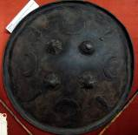 | ExC | UR
003547 | IRMT/UR/003547/ ExC / Wooden arrow with metal arrow head /003547 |  |  |  | Wooden arrow with metal arrow head. Made of bamboo and covered with leather at the lower part, has a sharp pointed iron head.  Material: bamboo, iron, leather  Condition: rusty  Size: 81 cm, 76 cm  # 93.782 (i) | 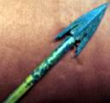 | ExC | UR
003548 | IRMT/UR/003548/ ExC / Wooden arrow with metal arrow head / 003548 |  |  |  | Wooden arrow with metal arrow head. Made of bamboo and covered with leather at the lower part, has a sharp pointed iron head.  Material: bamboo, iron, leather  Condition: rusty  (Roerichs’ collection)  Size: 81 cm, 76 cm  # 93.782 (ii) | 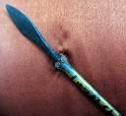 | ExC | UR
003549 | 003549 |  |  |  | Reproduction of N. Roerich | 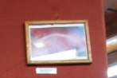 | P | UR
003550 | IRMT/UR/003550/ Pr_El / Walking stick with sword inside, 93.522/003550 |  |  |  | Walking stick with sword inside (wooden sheath).  With elephant shaped handle given to the Roerichs by the Maharaja of Mysore, carved with wood and has a cap of brass. Blade hidden inside, made in Britain.  Condition: slightly damaged  Size: 79,5 cm,  handle 10,6 cms,  blade -51,5 cms  # 93.522 | 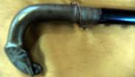 | Pr_El
003551 | IRMT/UR/003551/ ExC / Double saddle bag /003551 |  |  |  | Double saddle bag  (Roerichs’ collection) | 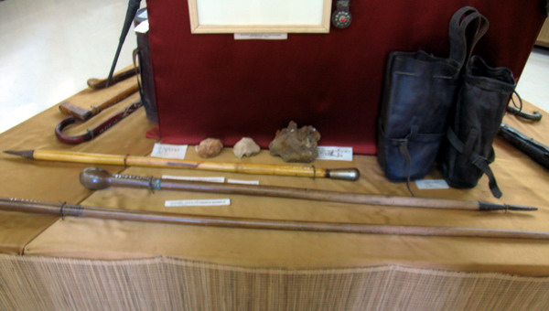 | ExC | UR
003552 | IRMT/UR/003552/ Ms/ Crystal / 003552 |  |  |  | Crystal  (Roerichs’ collection) | 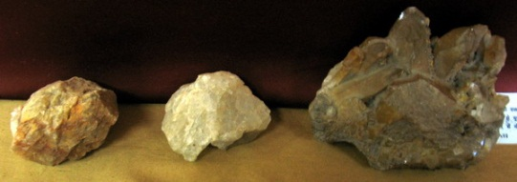 | Ms | UR
003553 | IRMT/UR/003553/ Ms/ Crystal / 003553 |  |  |  | Crystal  (Roerichs’ collection) |  | Ms | UR
003554 | IRMT/UR/003553/ Ms/ Crystal / 003554 |  |  |  | Crystal  (Roerichs’ collection) |  | Ms | UR
003555 | IRMT/UR/003555/ Pr_El / Walking stick, 93.545(xviii)/003555 |  |  |  | Walking stick 1,  (Roerichs’ collection)  Size 90 cm  #93.545 (xviii) |  | Pr_El | UR
003556 | IRMT/UR/003556/ Pr_El / Walking stick, 93.545(xvii)/0035 56 |  |  |  | Walking stick 2,  (Roerichs’ collection)  Size 108,5 cm  #93.545 (xvii) |  | Pr_El | UR
003557 | IRMT/UR/003557/ Pr_El / Walking stick, 93.545(xvi)/003557 |  |  |  | Walking stick 3,  (Roerichs’ collection)  Size 147,5 cm  #93.545 (xvi) |  | Pr_El | UR
003558 | IRMT/UR/003558/ ExC / Javelin 1/003558 | Wooden Javellin |  | mongolian | Wooden javelin 1, with both sides pointed iron head, Mongolian  Material: iron, wood  Condition: rusty  (Roerichs’ collection)  Size: Ht. 219,3 cm  # 93.517 (in catalogue 1996) | 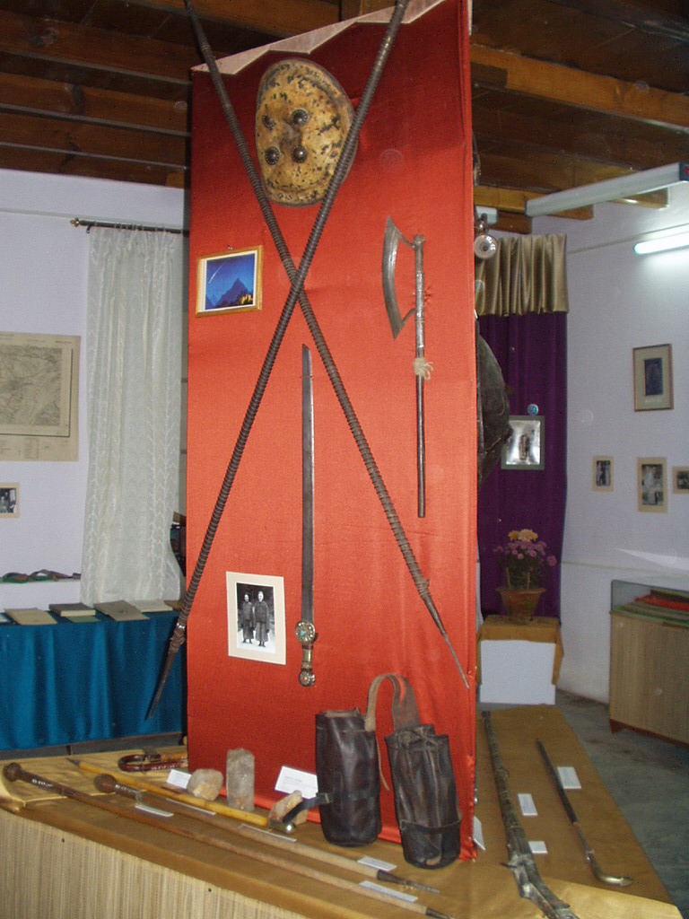 | ExC | UR
003559 | IRMT/UR/003559/ ExC / Javelin 2/003559 |  |  |  | Wooden javelin 2, with both sides pointed iron head, Mongolian  Material: iron, wood  Condition: rusty  (Roerichs’ collection)  Size: Ht. 219,3 cm  #93.518 (in catalogue 1996) |  | ExC | UR
003560 | IRMT/UR/003560/ ExC / Axe/ 003560 |  |  |  | Iron Axe made of iron and wood  Material: wood, iron  Condition: rusty  (Roerichs’ collection)  Size: blade – 29,4 cm, height - 63 cm | 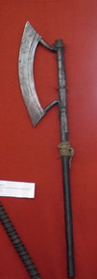 | ExC | UR
003561 | IRMT/UR/003561/ ExC / Tibetan sword, #93.523/003561 |  |  |  | Tibetan Sword with handle having round disc with carving and gems, in red and blue in lotus petals.  Material: iron  Condition: rusted  (Roerichs’ collection)  Size: L 84 x 3,5 cms sword  Handle  # 93.523 (93.521 in catalogue 1996) | 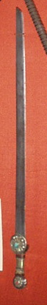 | ExC | UR
003562 | IRMT/UR/003562/ ExC / Leather shield/003562 | Leather shield |  |  | Shield made of horse or yak leather with four metal knobs.  Material: leather, metal  Condition: damaged  (Roerichs’ collection)  Size: Ht. 35,5 cms , w 30 cms  # 93.514 |  | ExC | UR
003563 |  |  |  |  | 1.Reproduction of N. Roerich, 1 photo |  | P | UR
003564 | IRMT/UR/003564/ ExC / Gun /003564 | Gun |  |  | Gun with brass (iron) stick, engraving and Bidsi work. Butt top is of wood and has a leather strap. Bent is of ash, middle has copper with brass on top.  Material: brass, wood  Condition: damaged  (Roerichs’ collection)  Size: Ht. 177,5 cms  # 93.516 | 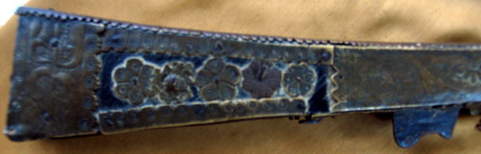 | ExC | UR
003565 | IRMT/UR/003565/ Pr_El / Walking stick, 93.545(20)/003565 |  |  |  | Walking stick 4,  (Roerichs’ collection)  Size 98 cm  #93.545 (20) | 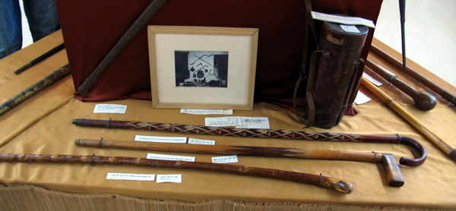 | Pr_El | UR
003566 | IRMT/UR/003566/ Pr_El / Walking stick, 93.545(12)/003566 |  |  |  | Walking stick 5,  (Roerichs’ collection)  Size 83 cm  #93.545 (12) |  | Pr_El | UR
003567 | IRMT/UR/003567/ Pr_El / Walking stick, 93.545(15)/003567 |  |  |  | Walking stick 6,  (Roerichs’ collection)  Size 96 cm  #93.545 (15) |  | Pr_El | UR
003568 | IRMT/UR/003568/ ExC / Leather round bag /003568 |  |  |  | Leather round bag  (Roerichs’ collection)  Size 11,5 x 29 cm  #93.525 | 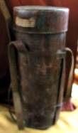 | ExC | UR
003569 | IRMT/UR/003569/ ExC / Bow 1/003569 |  |  |  | Leather covered wooden bow , used during the Roerichs’ expedition.  Material: bamboo, leather  Condition: rusted  (Roerichs’ collection)  Size: 103 cms  # 93.513 | 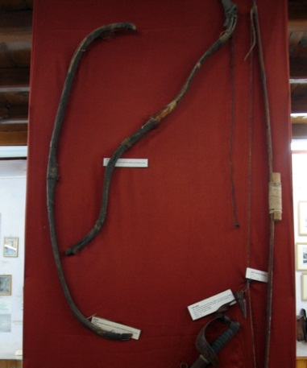 | ExC | UR
003570 | IRMT/UR/003570/ ExC / Bow2/003570 |  |  |  | Bow of Nicholas Roerich with leather strings  Material: bamboo, leather  Condition: rusted  Size: 104 cms  # 93.512 | 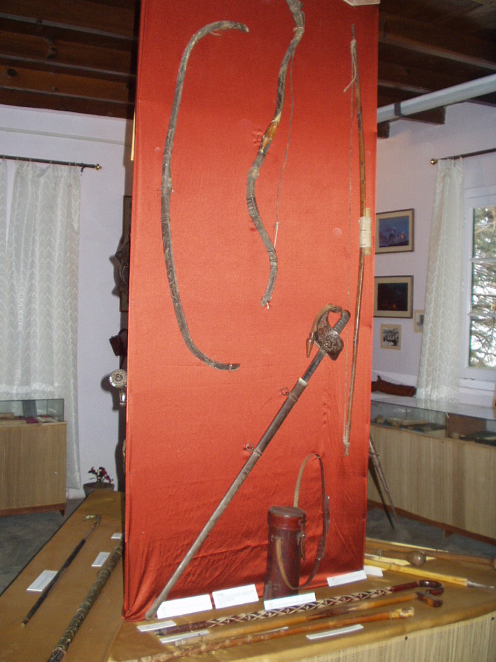 | ExC | UR
003571 | IRMT/UR/0035771/ ExC / Bow 3/003571 |  |  |  | Bow with strings  Material: wood, leather  Condition: rusted  (Roerichs’ collection)  Size: 143 cms  # 93.578 (i), 93.512 (?) (in catalogue 1996) |  | ExC | UR
003572 | IRMT/UR/003572/ ExC / Sword/003572 |  |  | John Stone, London | English Sword with a seal of emperor King Albert, carved design on the blade marking on the sheath –John Stone , London  Material: iron  Condition: rusted  (Roerichs’ collection)  Size: 101 cms  # 93.519 |  | ExC | UR
003573 | 003573 |  |  |  | 1 contemporary speaker | 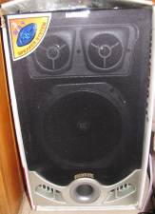 | F | UR
003574 | IRMT/UR/003574/ Ms/ Crystal / 003574 |  |  |  | Crystal, semitransparent  (Roerichs’ collection)  Size 12 x 9cm |  | Ms | UR
003575 | IRMT/UR/003575 Ms/ Crystal / 003575 |  |  |  | Crystal, transparent with clouds  (Roerichs’ collection)  Size 15 x 7,5 cm |  | Ms | UR
003576 | IRMT/UR/003576/ Ms/ Crystal / 003576 |  |  |  | Crystal non-transparent  (Roerichs’ collection)  Size 10 x 8cm |  | Ms | UR
003577 | IRMT/UR/003577/ Ms/ Crystal / 003577 |  |  |  | Crystal non-transparent  (Roerichs’ collection)  Size 9 x 4,5 |  | Ms | UR
003578 | IRMT/UR/003578/ B/ Sur les Pistes L’Asie Centrale, George De Roerich/ 003578 |  |  |  | Sur les Pistes L’Asie Centrale, George De Roerich, Librairie Orientaliste Paul Geuthner Paris 1933  13, Rue Jacob, Vi | 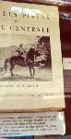 | B | UR
003579 | IRMT/UR/003579/ B/ Листы Сада Мории  1925/003579 |  |  |  | Листы Сада Мории  1925, 238 стр. | 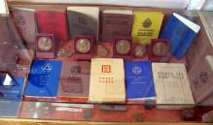 | B | UR
003580 | IRMT/UR/003580/ B/ Листы Сада Мории  1924/003580 |  |  |  | Листы Сада Мории  1924, 163 стр. |  | B | UR
003581 | IRMT/UR/003581/ B/ Листы из Градината На Мория /003581 |  |  |  | Листы из Градината На Мория, 1924, 157 p.  IRMT  #559. | 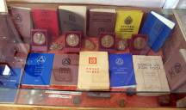 | B | UR
003582 | IRMT/UR/003582/ B/ Les Feulles di Jardin de Morya, 2/003582 |  |  |  | Les Feulles di Jardin de Morya, 2, 1925 1925, 299 p, imprime en France | 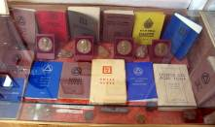 | B | UR
003583 | IRMT/UR/003583/ B/ Община 1927, Книга третья /003583 |  |  |  | Община 1927, Книга третья, 284 стр. | 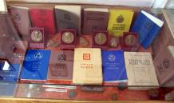 | B | UR
003584 | IRMT/UR/003584/ B/ Беспредельность, 1930/003584 |  |  |  | Беспредельность, 1930, imp.E.R.P.O. Zeluk,4,Rue Saulnier, Paris, 207 стр. |  | B | UR
003585 | IRMT/UR/003585/ B/ Чаша Востока, I Письма Махатм/ 003585 |  |  |  | Чаша Востока, I Письма Махатм, перевод Искандеp Ханум, 1925, ALATAS,  261 стр. |  | B | UR
003586 | IRMT/UR/003586/ B/ Основы Буддизма./ 003586 |  |  |  | Основы Буддизма, 1926  108 стр |  | B | UR
003587 | IRMT/UR/003587/ B/ Brotherood, 1937 IRMT 917 /003587 |  |  |  | Brotherood, 1937, 1967 USA, 318 p IRMT  #917 | 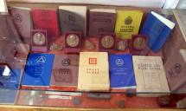 | B | UR
003588 | IRMT/UR/003588/ B/ Blatter aus dem Garten Morya /003588 |  |  |  | Blatter aus dem Garten Morya, 1924, USA 1953, 178 p. |  | B | UR
003589 | IRMT/UR/003589/ B/ Morijas Darza Lapaz No.621/2/003589 |  |  |  | Morijas Darza Lapaz, 1929, 170 p., IRMT  #621/2 |  | B | UR
003590 | IRMT/UR/003590/ B/ Swiat Ogna,1933/003590 |  |  |  | Swiat Ogna,1933, Warsawa, 340 p., IRMT  #587 |  | B | UR
003591 | IRMT/UR/003591/ B/ Listy z Moryovej Zahrady , Osveietenie, 1925 in Slovak language /003591 |  |  |  | Listy z Moryovej Zahrady , Osvietenie, 1925 in Slovak language, ММЦР, 1994,  216 p. |  | B | UR
003592 | IRMT/UR/003578/ B/ Signos Del Agni Yoga ,601/3 /3003592 |  |  |  | Signos Del Agni Yoga, Libreria N.B.Kier, Buenos Aires, 411p.  #601/3 |  | B | UR
003593 | IRMT/UR/003593 / B/ Book of Agni Yoga in Yiddish  1926 /003593 |  |  |  | Book of Agni Yoga in Yiddish (Hebrew),  1926  # 622 |  | B | UR
003594 | IRMT/UR/003594 / B/ Reprints from Urusvati Journal /003594 |  |  |  | Reprints from Urusvati Journal - 7 p. |  | B | UR
003595 | IRMT/UR/003595 / B/ Reprints from Urusvati Journal /003595 |  |  |  | Reprints from Urusvati Journal - 4 p. |  | B | UR
003596 | IRMT/UR/003596 / Ms/ Ancient stones/003596 |  |  |  | Ancient stones, 27 ps.  (Roerichs’ collection) | 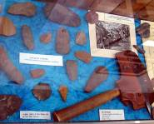 | Ms | UR
003597 | IRMT/UR/003597 / B/ G.N.Roerich, The Animal Style /003597 |  |  |  | G. N.Roerich, The Animal Style among the nomad tribes of northern Tibet, Seminariun Kondakovianum, Prague, 1930 | 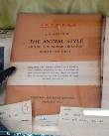 | B | UR
003598 | IRMT/UR/0035978/ B/ G.Roerich, Tibetan painting, 1925/ 003598 |  |  |  | G. Roerich, Tibetan paintings, 1925, Librairie Orientaliste Paul Geuthner, 95 with plates of thankhas |  | B | UR
003599 | IRMT/UR/003599/ M/ Hand –written notes by G.Roerich / 003599 |  |  |  | Hand –written notes by G. Roerich: the Origin of the Doctrine called The sun of the opened Lotus of the Doctrine.  Black note- book.  Cover damaged  68 pages | 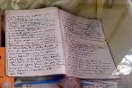 | M | UR
003600 | IRMT/UR/003600/ B/ Booklet about Urusvati Himalayan Research Institute /003600 |  |  |  | Booklet about Urusvati Himalayan Research Institute 4 lists with pictures  (Roerichs’ collection) |  | B | UR
003601 | IRMT/UR/003601/ B Annual report of Urusvati Himalayan Research Institute/003601 |  |  |  | Annual report of Urusvati Himalayan Research Institute 1929-1930  (Roerichs’ collection) |  | B | UR
003602 | IRMT/UR/003602/ J/ Journal of Urusvati Himalayan Research Institute /003602 |  |  |  | Journal of Urusvati Himalayan Research Institute vol.1, No.1  (Roerichs’ collection) |  | J | UR
003603 | IRMT/UR/003600/ J /Journal of Urusvati Himalayan Research Institute vol. III/003603 |  |  |  | Journal of Urusvati Himalayan Research Institute vol.III  (Roerichs’ collection) |  | J | UR
003604 | IRMT/UR/003604/ B /Tibetica 1, Dialects of Tibet, G. Roerich, The Tibetan Dialect of Lahul/ 003604 |  |  |  | Tibetica 1, Dialects of Tibet, G. Roerich, The Tibetan Dialect of Lahul, Urusvati Himalayan Research Institute  (Roerichs’ collection) | 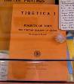 | B | UR
003605 | IRMT/UR/003605/ B / The Blue Annals, Part one by George N. Roerich /003605 |  |  |  | The Blue Annals, Part one by George N. Roerich, 1949, The Royal Asiatic Society of Bengal with G. Roerich notes  (Roerichs’ collection) |  | B | UR
003606 | IRMT/UR/003606/ B The Blue Annals, Part two by George N. Roerich /003606 |  |  |  | The Blue Annals, Part two by George N. Roerich, 1953, The Royal Asiatic Society of Bengal  (Roerichs’ collection) |  | B | UR
003607 | IRMT/UR/003607/ Ms/ Crystal / 003607 |  |  |  | Crystal  (Roerichs’ collection) |  | Ms | UR
003608 | IRMT/UR/003608/ Ms/ Crystal / 003608 |  |  |  | Crystal  (Roerichs’ collection) |  | Ms | UR
003609 | IRMT/UR/003609/ Ms/ Crystal / 003609 |  |  |  | Crystal  (Roerichs’ collection) |  | Ms | UR
003610 | IRMT/UR/003610/ Ms/ Crystal / 003610 |  |  |  | Crystal  (Roerichs’ collection) |  | Ms | UR
003611 | IRMT/UR/003611/ Ms/ Crystal / 003611 |  |  |  | Crystal  (Roerichs’ collection) |  | Ms | UR
003612 | IRMT/UR/003612/ Ms/ Crystal 003612 |  |  |  | Crystal  (Roerichs’ collection) |  | Ms | UR
003613 | IRMT/UR/003613/ Ms/ 003613 |  |  |  | Crystal  (Roerichs’ collection) |  | Ms | UR
003614 | IRMT/UR/003614/ Ms/ 003614 |  |  |  | Crystal  (Roerichs’ collection) |  | Ms | UR
003615 | IRMT/UR/003615/ Ms/ 003615 |  |  |  | Crystal  (Roerichs’ collection) |  | Ms | UR
003616 | IRMT/UR/003616/ Ms/ Crystal/  003616 |  |  |  | Crystal  (Roerichs’ collection) |  | Ms | UR
003617 | IRMT/UR/003617/ B/ Ю.Н.Рерих, Тибетско-русско-английский словарь с санскритскими параллелями, вып.6/ 003617 |  |  |  | Ю. Н. Рерих, Тибетско-русско-английский словарь с санскритскими параллелями, вып.6  Издательство «Наука» 1986 с.360 | 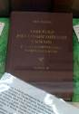 | B | UR
003618 | IRMT/UR/003618/ / B/ Знамя Мира Русский комитет Пакта Рериха в Харбине, Отчет  /003618 |  |  |  | Знамя Мира  Русский комитет Пакта Рериха в Харбине, Отчет  5.09.1934 24 с.Printed in Manchuria |  | B | UR
003619 | IRMT/UR/003619/ B/ The Roerich Pact and Banner of Peace  / 003619 |  |  |  | The Roerich Pact and Banner of Peace published by the Roerich Pact and Banner of Peace Committee New York, N.Y. 1947 |  | B | UR
003620 | IRMT/UR/003620/ B/ Culture by Richard Rudzitis/ 003620 |  |  |  | Culture by Richard Rudzitis, Flamma, Inc. Publishing New York 1937, 40 p. |  | B | UR
003621 | IRMT/UR/003621/ B/ Roerich Banner of Peace / 003621 |  |  |  | Roerich Banner of Peace, Roerich Museum Press, New York,1931, 51 p. |  | B | UR
003622 | IRMT/UR/003622/ B/ A New Outpost of Science / 003622 |  |  |  | A New Outpost of Science, “Urusvati” Himalayan Research Institute of Roerich Museum, 16 p., 2 booklets |  | B | UR
003623 | IRMT/HE_U3/003623/ M / Letter to N. Roerich from the Naggar people / 003623 |  |  |  | Letter to N.Roerich from Naggar people asking to open a Sanskrit school dd 7.5.37, 2 p., Paper damaged  (Roerichs’ collection) | 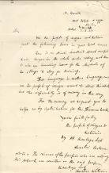 | M | HE_U3
003624 | IRMT/HE_U3/003624/ M / Sheet of paper in Tibetan, probably in G. Roerich handwriting  / 003624 |  |  |  | Sheet of paper in Tibetan, probably in G. Roerich’s handwriting,  Size 20 x 12,5 cm  (Roerichs’ collection) |  | M | HE_U3
003625 | IRMT/HE_U9/003625/ Doc / TASS News from SU /003625 |  |  |  | News from SU, TASS dd 1.9.1944, 2.8.1944 |  | Doc | HE_U9
003626 | IRMT/HE_U9/003626/ B / File with articles and booklets devoted to N. Roerich /003626 |  |  |  | File with articles and booklets devoted to N. Roerich, many with author’ signatures, 10 pcs |  | B | HE_U9
003627 | IRMT/HE_U9/003627/ B / N. Roerich memorial volume /003627 |  |  |  | N. Roerich memorial volume, Youth’ Art & Culture Circle, Bombay  In thin paperback, 49 p with reproductions |  | B | HE_U9
003628 | IRMT/HE_U9/003628/ J / Rays from Rose Cross  Nov 1921  905/003628  IRMT/HE_U9/003628_1/ J / Rays from Rose Cross  Nov 1921  905/003628_1 |  |  |  | Rays from Rose Cross  Nov 1921  905  Roerich name  Feb 1922 p 363-400  906  Roerich name |  | J | HE_U9
003629 | IRMT/HE_D1/003629/ Pr_El/ Old thermometer 003629 |  |  |  | Old thermometer on wooden plate  (Roerichs’ collection)  Size 21 x 4,8 cm | 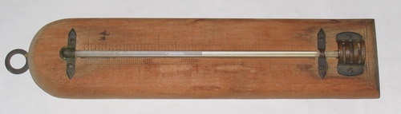 | Pr_El | HE_D1
003630 | IRMT/HE_D1/003630/ Pr_ Cl / Samples of fabric /003630 |  |  |  | Samples of fabric, (Devika Rani’s collection)  9 pcs + 13 pcs |  | Pr_Cl | HE_D1
003631 | IRMT/HE_D1/003631/ Pr_ El / Mantle for burners/003631 |  |  |  | Mantle for burners  Ancos (5 pcs)  Fargo (4 pcs)  (Roerichs’collection) |  | Pr_El | HE_D1
003632 | IRMT/HE_U3/003632/ B / Bibliotheca Indica No 729  Vol. I, Fasc. III.  Calcutta,1989, /003632 |  |  |  | Bibliotheca Indica:  Collection Of Oriental Works  Published By The Asiatic Society Of Bengal.  New Series,  Vol. I, Fasc. III.  Calcutta,1989, 96 p  No 729 |  | B | HE_U3
003633 | IRMT/HE_U3/003633/ B / Bibliotheca Indica: New Series, No 1134  Fasc. I  Calcutta,1905  /003633 |  |  |  | Bibliotheca Indica:  Collection Of Oriental Works  Published By The Asiatic Society Of Bengal.  New Series,  Fasc. I  Calcutta,1905, 565 p  G.Roerich note  Paperback damaged  No 1134 |  | B | HE_U3
003634 | IRMT/HE_U3/003634/ B / Н.Лосский  Ценность и бытие No.1092  /003634 |  |  |  | Н. Лосский  Ценность и бытие,  YMCA Press, Paris 1931  P 135,  With a dedication to N. Roerich  No.1092 |  | B | HE_U3
003635 | IRMT/HE_U3/003635/ B / Материалы научной конференции библиотеки ТГУ No 88/003635 |  |  |  | Материалы научной конференции библиотеки ТГУ, p 124, 1972,  No 88 |  | B | HE_U3
003636 | IRMT/HE_U3/003636/ B / The school of surveying No 854/ 003636 |  |  |  | The school of surveying of the American Geographical Society of New York, 1927  P 16, Hand written: George Roerich  No 854 |  | B | HE_U3
003637 | IRMT/HE_U3/003637/ B / Руководство дляУнтер-офицеров, часть 2, No.895.003637 |  |  |  | Руководство для Унтер-офицеров, часть 2, Кавалерия, Издание военного журнала «Часовой» LA Centinelle – 29, rue de Colisee, Paris, 117 p, Name of ЮР and many notes in G.Roerich handwriting, No.895 |  | B | HE_U3
003638 | IRMT/HE_U3/003638/ B / Generalissimo Chiang Kai-Sheko No.783/003638 |  |  |  | Generalissimo Chiang Kai-Sheko, from July 1937-january 1944  Newman and CO. Limited, Calcutta, India, 129 p  No.783 |  | B | HE_U3
003639 | IRMT/HE_U3/003639/ B / Bibliotheca Indica Vol III, Fasc. II  Calcutta,1897/003639 |  |  |  | Bibliotheca Indica:  Collection Of Oriental Works  Published By The Asiatic Society Of Bengal.  New Series,  Vol III, Fasc. II  Calcutta,1897, 597-200 p  Paperback damaged  No 896 |  | B | HE_U3
003640 | IRMT/HE_U3/003640/ J / The Indian Journal of Political Science Vol.VI, No.4 , Apr-June 1945/ 003640 |  |  |  | The Indian Journal of Political Science Vol.VI, No.4 , Apr-June 1945,190-300 p  No.1071 |  | J | HE_U3
003641 | IRMT/HE_U3/003641/ J / The Indian Journal of Political Science Vol.VII, No.1&2 , Jul-Sep,Oct-Dec 1945/003641 |  |  |  | The Indian Journal of Political Science Vol.VII, No.1&2 , Jul-Sep, Oct-Dec 1945,303-411p  No.1072 |  | J | HE_U3
003642 | IRMT/HE_U9/003642/ Ms / Crystal druza /003642 |  |  |  | Crystal druza, semi-transparent  (Roerichs’ collection)  Size 9 x 8,5 x 10cm |  | Ms | HE_U9
003643 | 003643 |  |  |  | Alexander Pushkin  Selected works  Progress – Russian Classics Series, Moscow, 1974  Volume One. Poetry  208 p. |  | B | HE_U1
003644 | 003644 |  |  |  | Alexander Pushkin  Selected works, Progress – Russian Classics Series, Moscow, 1974, Volume Two. Prose works, 234 p. |  | B | HE_U1
003645 | 003645 |  |  |  | H. L. Gee  Tales of to-day, Wyman & sons, London, 1944, 148 p. |  | B | HE_U1
003646 | 003646 |  |  |  | Victor Buksbazen, Miriam the virgin of Nazareth  Miriam the virgin of Nazareth,  Continental Press, Philadelphia, 1963, 239 p.  No 522 |  | B | HE_U1
003647 | 003647 |  |  |  | Ezra Pounds, Selected cantos  New directions books, New York,1970, 119 p.  No 184 |  | B | HE_U1
003648 | 003648 |  |  |  | The call divine, Vol.20 “UshaKunj”, Bombay,1972, 320 p.  No 140 |  | B | HE_U1
003649 | 003649 |  |  |  | Cheiro, When were you born?  Herbert Jenkins Limited, London, 121 p.  No 551 |  | B | HE_U1
003650 | 003650 |  |  |  | Conversation with bhagavansrisaihyasai baba  VrajBrindavanPress , Bangalore, 1978, 197 p.  No 166 |  | B | HE_U1
003651 | 003651 |  |  |  | Pitts Sanborn, Prima donna,  Vol 1, Longman,green and co. 1929, USA, 259 p.  No 814/2 |  | B | HE_U1
003652 | 003652 |  |  |  | Pitts Sanborn, Prima donna, Vol 1, Longman,green and co. 1929, USA.  259 p.  No 814/2 |  | B | HE_U1
003653 | 003653 |  |  |  | Pitts Sanborn, Prima donna  Vol 2, Longman,green and co. 1929, USA, 616 p.  No 814/1 |  | B | HE_U1
003654 | 003654 |  |  |  | J.B. West  Upstairs at the white house,  my life with the first ladies  warner paperback library edition,1974, USA  405 p.  No 317 |  | B | HE_U1
003655 | 003655 |  |  |  | Eric Dickinson  A Florentine night  Florence, Italy, 1931  90 p. (with author’s signature)  No 408 |  | B | HE_U1
003656 | 003656 |  |  |  | Helen Maggines  Above Suspicion, Fontana books, London,1967, 154 p  No 451 |  | B | HE_U1
003657 | 003657 |  |  |  | Helen Hayes  On reflection, A Fawcett Crest Book, USA, 1969, 224 p. (Devika Rani from…Dee 1970)  No 160 |  | B | HE_U1
003658 | 003658 |  |  |  | Dr. Josian Oldfield  The dry diet cure, The C.W. Daniel company, London,1924  132 p.  No 485 |  | B | HE_U1
003659 | 003659 |  |  |  | Patricia Wentworth, Ladies’ Bane, London, Hodder and Stoughton, 1954, 256 p.  No 477 |  | B | HE_U1
003660 | 003660 |  |  |  | Herbert Jenkins, The bindles on the rock, A Herbert Jenkins’ book, London, GB, 192 p.  No 511 |  | B | HE_U1
003662 | 003662 |  |  |  | P.G. Wodehouse, Summer Moonshine, A Herbert Jenkins Limited, New York, 312 p.  No 490 |  | B | HE_U1
003663 | 003663 |  |  |  | P.G. Wodehouse  The girl on the boat  A Herbert Jenkins Limited, London, 312 p.  No 491 |  | B | HE_U1
003664 | 003664 |  |  |  | P.G. Wodehouse  Thank you, Jeeves, A Herbert Jenkins Limited, London,  312 p.  No 454 |  | B | HE_U1
003665 | 003665 |  |  |  | P.G. WODENHOUSE  Carry on, Jeeves!  Pocket Books, Inc., New York, 1948, 258 p.  No 459 |  | B | HE_U1
003666 | 003666 |  |  |  | P.G. WODENHOUSE  Jeeves, Pocket Books, Inc., New York, 1945, 225 p.  No 458 |  | B | HE_U1
003667 | 003667 |  |  |  | P.G. WODENHOUSE  The best of Wodehouse  Pocket Books, Inc., New York, 1949, 266 p.  No 462 |  | B | HE_U1
003668 | 003668 |  |  |  | PATRICK O’HIGGINS  Madame, Dell Publishing co., inc. New York,1978  367 p.  No 322 |  | B | HE_U1
003669 | 003669 |  |  |  | P.G. WODENHOUSE  Lord emsworth and others  A Herbert Jenkins Limited, London, 1938, 312 p.  No 564 |  | B | HE_U1
003670 | 003670 |  |  |  | P.G. WODENHOUSE  Full moon, A Herbert Jenkins Limited, London, 252 p.  No 567 |  | B | HE_U1
003671 | 003671 |  |  |  | P.G. WODENHOUSE  Thank you, Jeeves, A Herbert Jenkins Limited, London,  312 p.  No 566 |  | B | HE_U1
003672 | 003672 |  |  |  | P.G. WODENHOUSE  Doctor sally, A Herbert Jenkins Limited, London, 1952, 326 p.  No 492 |  | B | HE_U1
003673 | 003673 |  |  |  | P.G. WODENHOUSE  Barmy in wonderland, A Herbert Jenkins Limited, London, 1952, 221 p.  No 493 |  | B | HE_U1
003674 | 003674 |  |  |  | P.G. WODENHOUSE  Indiscretions of archie  A Herbert Jenkins Limited, London, 320 p.  No 495 |  | B | HE_U1
003675 | 003675 |  |  |  | P.G. WODENHOUSE  The adventures of Sally  A Herbert Jenkins Limited, London, 223 p.  No 489 |  | B | HE_U1
003676 | 003676 |  |  |  | P.G. WODENHOUSE  If I were you, A Herbert Jenkins Limited, London,  280 p.  No 565 |  | B | HE_U1
003677 | 003677 |  |  |  | P.G. WODENHOUSE  Mulliner nights, A Herbert Jenkins Limited, London,  312 p.  No 496 |  | B | HE_U1
003678 | 003678 |  |  |  | P.G. WODENHOUSE  Journalist, A. & C. black, Ltd, London, 1950, 247 p.  No 498 |  | B | HE_U1
003679 | 003679 |  |  |  | P.G. WODENHOUSE  The clicking of cuthbert  A Herbert Jenkins Limited, London, 256 p.  No 559 |  | B | HE_U1
003680 | 003680 |  |  |  | P.G. WODENHOUSE  Pigs have wings, A Herbert Jenkins Limited, London, 1952  219p.  No 558 |  | B | HE_U1
003681 | 003681 |  |  |  | P.G. WODENHOUSE  The little nugget  A Herbert Jenkins Limited, London, 1950  220 p.  No 562 |  | B | HE_U1
003682 | 003682 |  |  |  | P.G. WODENHOUSE  Heavy weather  A Herbert Jenkins Limited, London, 1933  256 p.  No 563 |  | B | HE_U1
003683 | 003683 |  |  |  | P.G. WODENHOUSE  Inimitable Jeeves  A Herbert Jenkins Limited, London,  255 p.  No 556 |  | B | HE_U1
003684 | 003684 |  |  |  | P.G. WODENHOUSE  The code of the woosters  A Herbert Jenkins Limited, London,  312 p.  No 494 |  | B | HE_U1
003685 | 003685 |  |  |  | P.G. WODENHOUSE  Quick service  A Herbert Jenkins Limited, London,  252 p.  No 455 |  | B | HE_U1
003686 | 003686 |  |  |  | P.G. WODENHOUSE  young men in spats  A Herbert Jenkins Limited, London,  312 p.  No 456 |  | B | HE_U1
003687 | 003687 |  |  |  | P.G. WODENHOUSE  The coming of bill  A Herbert Jenkins Limited, London,  252 p.  No 500 |  | B | HE_U1
003688 | 003688 |  |  |  | P.G. WODENHOUSE  Much obliged, jeeves  A Herbert Jenkins Limited, London, 1971  191 p.  No 488 |  | B | HE_U1
003689 | 003689 |  |  |  | PATRICK SUSKIND  Perfume  A king penguin ,Great Britain, 1986, 263 p. |  | B | HE_U1
003690 | 003690 |  |  |  | GEORG SAVA  A ring at the door  Faber and faber, London  208 p.  No 831 |  | B | HE_U1
003691 | 003691 |  |  |  | THE SPIRITUAL HEALER  Journal of healing and philosophy  VOL.5 No8, august 1957  384 p.  No 620 |  | B | HE_U1
003692 | 003692 |  |  |  | THE SPIRITUAL HEALER  Journal of healing and philosophy  VOL.5 No3, march 1957  142 p.  No 620 |  | B | HE_U1
003693 | 003693 |  |  |  | THE SPIRITUAL HEALER  Journal of healing and philosophy  VOL.1 No7, July,1953  316 p.  No 620 |  | B | HE_U1
003694 | 003694 |  |  |  | THE CORRECT GUIDE TO LETTER WRITING  Frederick Warne and co., New York, 197 p.  No 715 |  | B | HE_U1
003695 | 003695 |  |  |  | EDQAR WALLACE  The secret house  Ward, Lock & co., limited, London 1954, 190 p.  No 514 |  | B | HE_U1
003696 | 003696 |  |  |  | DOROTHY DENNISON  Physician heal thyself  The paternoster press, London,1955, 256 p.  No 342 |  | B | HE_U1
003697 | 003697 |  |  |  | Herbert Jenkins  Mrs. Bindle  Herbert Jenkins limited, London, 188 p.  No 512 |  | B | HE_U1
003698 | 003698 |  |  |  | CLEMENCE DANE  Moonlight is silver  A play in tree acts  London, William Heinemann Ltd., 1934, 101 p.  No 541 |  | B | HE_U1
003699 | 003699 |  |  |  | DR. J. ORR  Lady of the Command  Astro-medical & oriental publications, Raichur, 1964  261 p., (with author’s signature)  No 244 |  | B | HE_U1
003700 | 003700 |  |  |  | SATYA SAI SPEACS  Vol.5 Sanathanasarathi office, Andhra Pradesh,1967, 250 p.  No 239 |  | B | HE_U1
003701 | 003701 |  |  |  | ANTHONY BORGIA  Life in the world unseen  Odhans press limited, London.1954, 191 p.,  No 544 |  | B | HE_U1
003702 | 003702 |  |  |  | JOHN CREASEY  The Toff at the fair  Hodder and Stoughton, London, 1954, 190 p.,  No 513 |  | B | HE_U1
003703 | 003703 |  |  |  | ETHEL M. DELL  The swindler and other stories  T.Fisher Unwin, London, 1914  401 p.,  No 524 |  | B | HE_U1
003704 | 003704 |  |  |  | W. SOMERSET MAUGHAM  The razor’s edge  William Heinemann ltd , London,1944, 284 p.  No 325 |  | B | HE_U1
003705 | 003705 |  |  |  | TRUE CONFESSIONS OF INDIAN GIRLS  Published by Mast Qalandar, Lahore, 1941, 168 p.  No 593 |  | B | HE_U1
003706 | 003706 |  |  |  | С Маршак  Сказка об умном мышонке  Детгиз, 1959, Москва  14 p |  | B | HE_U1
003707 | 003707 |  |  |  | К. ЧУКОВСКИЙ  Тараканище  Детгиз, 1959, Москва  14 р |  | B | HE_U1
003708 | 003708 |  |  |  | Корней Чуковский  Муха-цокотуха  Детгиз, 1960  14 р |  | B | HE_U1
003709 | 003709 |  | DevikaRani’s books |  | J.M. BARRIE  Peter Pan, or the boy who would not grow up  Hodder and Stoughton ltd. London, 1942, 192 p.  No 548 |  | B | HE_U1
003710 | IRMT/HE_U3/003710/B/ Dr. Leon Wieger… Vies Chinoises Du Buddha  Buddhisme. Tome II  No1219/003710 |  |  |  | Dr. Leon Wieger S.I.Les Vies Chinoises Du Buddha  Buddhisme. Tome II, 1913, 453  Mark: George Roerich 1928  No1219 |  | B | HE_U3
003711 | IRMT/HE_U3/003711/B/ … Baron M.de Taube  La Politique Russe …la Fina de L’E,pire Des Tzar No.1308  /003711 |  |  |  | Memoires du Baron M.de Taube  La Politique Russe D’avant-Guerre et la Fina de L’E,pire Des Tzar ( 1904-1917), 1928, 412 p  Paris, Librairie ernest Leroux Mark: George Roerich  No.1308 |  | B | HE_U3
003712 | IRMT/HE_U3/003712/B/ A.Meillet,Introduction a L’Etude Comparative des Langues / 003712 |  |  |  | A.Meillet, Introduction a L’Etude Comparative des Langues Indo-Europeennes, 1924, Librairie Hachtte, 464 p, No.1302 |  | B | HE_U3
003713 | IRMT/HE_U3/003713/B/ Georges Poisson, Les Aryens  Etude Liguistique No.1181  /003713 |  |  |  | Georges Poisson, Les Aryens  Etude Liguistique, Ethnologique et Prehistotique, Payot, Paris, 1934,272 p  Mark: G de Roerich  No.1181 |  | B | HE_U3
003714 | IRMT/HE_U3/003714/B/ H.Buttgenbach  Les Mineraux et des Roches, No.1310/003714 |  |  |  | H.Buttgenbach  Les Mineraux et des Roches, etudes pretiques de cristallographie …, 1928 Imprime en Belgique, 756 p Urusvati stamp  No.1310 |  | B | HE_U3
003715 | IRMT/HE_U3/003714/B/ Memoires du Marechal Joffre (1910-1817), Tom 1/ 003715 |  |  |  | Memoires du Marechal Joffre (1910-1817), Tom 1, Paris, Librairie Plon , 491 p, with maps  G.Roerich’s signature |  | B | HE_U3
003716 | IRMT/HE_U2/003716/Ms/ stone Pirit/003716 |  |  |  | Pirit, mineral stone  Grey metal colour with numerous facets  Size 4 x 2,5 x 1 cms | 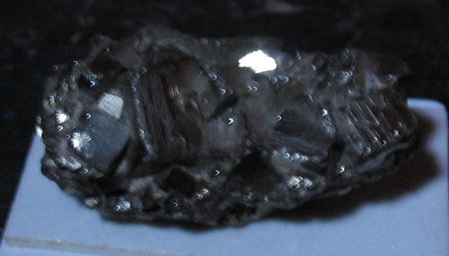 | B | HE_U2
003717 | IRMT/HE_U2/003717/Et/ Tibetan badge/ 003717 |  |  |  | Tibetan badge with golden and black Tibetan design  (Roerichs’ collection)  Rusty  Size 4 cms |  | B | HE_U2
003718 | IRMT/ AGR /003718/Pr_F/ Book-case /003718 |  |  |  | Book-case of dark wood with five shelves  (Roerichs’ collection)  # 93.645 | 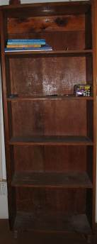 | Pr_F | AGR
003719 | IRMT/ AGR /003719/Pr_F/ Rectangular table /003719 |  |  |  | Rectangular table of dark wood  (Roerichs’ collection)  # 93.810 | 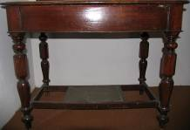 | Pr_F | AGR
003720 | IRMT/ AGR /003720/Pr_F /Rectangular table / 003720 | table |  |  | Rectangular table of dark wood  (Roerichs’ collection) |  | Pr_F | AGR
003721 | IRMT/ HE_D1 /003721/Pr_F /wood stool /003721 |  |  |  | Plain wood stool  Dark wood  (Roerichs’ collection)  # 93.604 |  | Pr_F | HE_D1
003722 | IRMT/ HE_U8 /003722/Np/ N/p clippings about art 1931/003722 |  |  |  | N/p clippings about art 1931  (Roerichs’ collection) |  | Np | HE_U8
003723 | IRMT/ Ac/003723/Pr_F /Rectangular table / 003723 |  |  |  | Rectangular table of dark wood  (Roerichs’ collection)  # 93.684 | 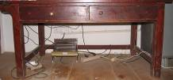 | Pr_F | Ac
003724 | IRMT/ Ac/003724/Pr_F /Rectangular table / 003724 |  |  |  | Big table of dark wood  (Roerichs’ collection)  # 93.821 | 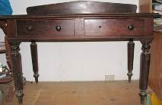 | Pr_F | Ac
003725 | IRMT/HE_U3/003725/M / Sheets of paper , Sketches/ 003725 |  |  |  | Sheets of paper various notes probably by G. Roerich ( 7 pcs) and N. Roerich (1 pcs)  Sketches by N Roerich ( 1p)  G. Roerich (?) ( 3 pcs) |  | M | HE_U3
003726 | IRMT/HE_D3/003726/M / Expedition hammer / 003726 |  |  |  | Expedition hammer  Steel and wood  (Roerichs’ collection)  Rusty  Size 33 x 18 cm  # 93.531 (2) | 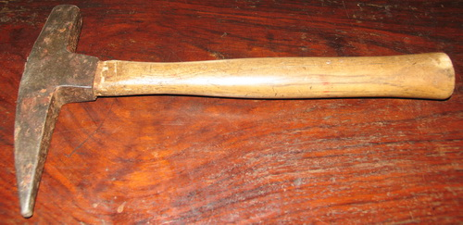 | M | HE_D3
003727 | IRMT/HE_D3/003727 Oth/ printing blocks in a box 47 pcs / 003727 |  |  |  | Box with printing blocks of the Urusvati Institute  Numbered blocks 535 ( Roman letters 20,19,18,17,16,15,14,  12,10,9,8/2,7,6,5,4,3,2,1)-20 pcs  Blocks without numbers 23 + 3 small – 27  (Roerichs’ collection) | 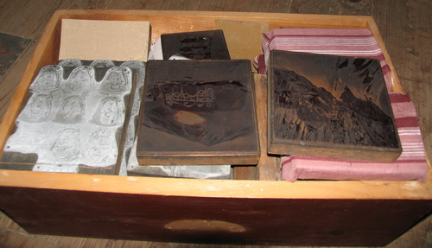 | Oth | HE_D3
003728 | IRMT/HE_U3/003728 Doc/ File with Letters to  S.Roerich …/003728 |  |  |  | File with Letters to  - S.Roerich with cancer cells dd June 26, 1934  - N.Roerich d 30.Nov, 1946  - To G.Roerich (?) dd 5.2.1944 on New dictionary  - To N.Roerich dd 15, Jan, 1941  - Unidentified dd 29, June 1941  Speech of Mme de Vaux Phalipau |  | Doc | HE_U3
003729 | IRMT/ Ac/003729/Pr_F /big sofa / 003729 |  |  |  | Big sofa  (Roerichs’ collection) | 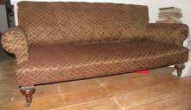 | Pr_F | Ac
003730 | IRMT/ HE_Stock room/003730/Pr_F / Wooden chair  / 003730 |  |  |  | Wooden chair  (Roerichs’ collection)  # 93.113 | 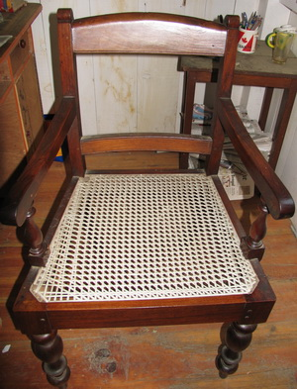 | Pr_F | HE_Stock room
003731 | IRMT/ HE_Stock room /003731/Pr_F / Wooden Armchair /003731 |  |  |  | Wooden Armchair  (Roerichs’ collection) | 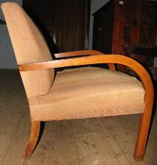 | Pr_F | HE_Stock room
003732 | IRMT/ HE_D1 /003732/MS / Crystal /003732 |  |  |  | Crystal, transparent  (Roerichs’ collection)  Size H 7 x d 7 cms  # 93.355 |  | MS | HE_D1
003733 | IRMT/ HE_U9 /003733/ List 1 |  |  |  | List 1. Список 1  Библиотека. Правый диван, нижний выдвижной ящик (для ценных ветхих материалов, материалов с подписями) IRMT/HE_U9/000130/Pr_F/ Sofa combined with bookcase/ 00013,  # 93.449 |  |  | HE_U9
003734 | IRMT/ HE_U9 /003734/ List 2 |  |  |  | List 2/ Список 2  Библиотека. Левый диван, нижний выдвижной ящик  ( газеты, журналы, религиозная литература и т.д.)  IRMT/HE_U9/000131/Pr_F/ Sofa combined with bookcase/ 000131,  # 93.450 |  |  | HE_U9
003735 | IRMT/ HE_D1 /003735/ List 3 |  |  |  | List 3. Список 3  Список 3  Гостиная, первый этаж, буфет, правый отсек  ( для ценных ветхих материалов, материалов с подписями)  IRMT/HE_D1/000909/Pr_F/ Sideboard / 000909  # 93.657 |  |  | HE_D1
003736 | IRMT/ HE_D1/ 003736/ List 4 |  |  |  | List 4. Список 4  Список 4  Гостиная, первый этаж, буфет, левый отсек  IRMT/HE_D1/000909/Pr_F/ Sideboard / 000909  # 93.657 |  |  | HE_D1
003737 | IRMT/ HE_U8/ 003737/ List 5 |  |  |  | List 5. Список 5  Кабинет Девики, второй этаж, комод слева от письменного стола  IRMT/HE_U8/000282/ Pr_F / Chest of drawers / 000282,Black number: #86  Письменный стол Девики, IRMT/HE_U8/000276/ Pr_F/Writing desk / 000276 |  |  | HE_U8
003738 | IRMT/ HE_U5/ 003738/ List 6 |  |  |  | List 6. Список 6  Второй этаж. Комната сыновей, встроенный шкаф  IRMT/HE_U5/000249/ Pr_F /Built-in bookcase / 000249 |  |  | HE_U5
003739 | IRMT/ HE_U9/ 003739/ List 7 |  |  |  | List 7. Список 7  Список 7  Второй этаж , библиотека, комод у стены # 93.454  IRMT/HE_U9/000132/Pr_F/ Built-in chest of drawers combined with bookshelves / 000132 |  |  | HE_U9
003740 | IRMT/ HE_U9/ 003740/ List 8 |  |  |  | List 8. Список 8  Второй этаж, библиотека, комод у окна.  IRMT/HE_U9/000133/Pr_F/Wooden Chest of drawers/ 000133  # 93.453 |  |  | HE_U9
003741 | IRMT/HE_U9/003741/ List 9/ |  |  |  | List 9. Список 9  Список 9  Второй этаж, библиотека, комоды у входа  IRMT/HE_U9/000128/Pr_F/ Chest of drawers /000128  # 93.451 |  |  | HE_U9
003742 | IRMT/HE_U1/003742/ List 10/ |  |  |  | List 10. Список 10  Список 10  Второй этаж , гостиная, открытый стеллаж  IRMT/HE_U1/000124/Pr_F/Book case /000124  # 93.465 |  |  | HE_U1
003743 | IRMT/HE_U2/003743/ List 11/ |  |  |  | List 11. Список 11  Второй этаж , кабинет Е.И., письменный стол  IRMT/HE_U2/000071/Pr_F/ Writing desk / 000071  # 93.472 |  |  | HE_U2
003744 | IRMT/HE_U3/003744/ List 12 |  |  |  | List 12. Список 12  Спальня Е.И.Рерих, невысокий двустворчатый шкаф около кровати  IRMT/HE_U3/000088/Pr_F/ Wooden bookcase/000088,  Редкие книги в ветхом состоянии.  # 93.475 |  |  | HE_U3
003745 | IRMT/HE_U3/003745/ List 13 |  |  |  | List 13. Список 13  Второй этаж. Спальня Е.И., встроенный шкаф  IRMT/HE_U3/000093/Pr_F/ Wooden built-in bookcase / 000093 |  |  | HE_U3
003746 | IRMT/ HE_U6/ 003746/List 14/ |  |  |  | List 14. Список 14  Список 14  Второй этаж. Ванная мальчиков D6, сундуки:  Сундук IRMT/HE_U6/000322/Pr_  Сундук IRMT/HE_U6/000323/Pr_F/Metal coffer / 000323,  F/Metal coffer / 000322  # 93.626 |  |  | HE_U6
003747 | IRMT/HE_U9/003747/Dr/ G.Roerich – Drawing with signature and notes/ 003747 |  |  |  | G.Roerich – Drawing with signature and notes  Size 44 x 30 cm |  |  | HE_U9
003748 | IRMT/HE_U9/003748/Dr/ G.Roerich – Drawing with signature and notes/ 003748 |  |  |  | G.Roerich (?) – Drawing and notes in Sanskrit |  |  | HE_U9
003749 | IRMT/HE_U9/003749/Doc/ Book of one hundred World Peace seals / 003749 |  |  |  | Book of one hundred World Peace seals ( stamps) 6 pages nearly full  (Roerichs’ collection) |  |  | HE_U9
003750 | IRMT/ HE_U8 /003750/Np/ N/p clippings about Tibetan ceremonies 1931/003750 |  |  |  | N/p clippings about Tibetan ceremonies |  |  | HE_U8
003751 | IRMT/ HE_U8 /003751/El/ Metal round box for typewriter ribbon /003751 |  |  |  | Metal round box for typewriter ribbon, Remitico – Paragon ribbon, Made in British empire by Remington Typewriter, USA  Size 6,7 x 2,2 cms  (Roerichs’ collection) | 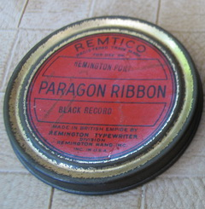 |  | HE_U8

